NASCONA ASC October 2, 2022

Jeremy opened meeting with Serenity Prayer
Chuck read 12 Traditions
Luke read 12 Concepts
Jeremy read purpose of ASC and Unity Statement
Jeremy read Service Prayer
Scott called role of Groups
Groups present:
BLTN
Happy, Joyous and Free
New Hope
RIP
Show Up and Grow Up

Scott called role of Trusted Servants
Trusted Servants present:
Facilitator – Jeremy
Treasurer - Debbie
Co-Treasurer - Vicki
Recorder – Scott
RCM1 – Shawn
H&I – Robert
PR – Larry
Activities Co Facilitator – Justin Michelle
Webservant - Ron

REPORTS
Scott read Recorders report – see Sep 2022 ASC Minutes
Treasurer Report
Treasurer Report
October 2, 2022

Bank balance: $7,826.11
Prudent Reserve: ($900.00)
FBTL: [$1,500.00]

BALANCE: $5,426.11

Checks not cleared:
None – all have cleared

Deposits: $285.60 TOTAL
$207.60 (cash)
$0 (Square)
$78.00 (Venmo)

Deposits not credited: N/A

WORKING BALANCE: $5,426.11 [EVERYTHING BALANCES]

I just realized I did not make the quarterly payment to Region, and will do so today.

To circle back… I haven’t seen the minutes from last month, but these two issues need to be addressed:

- Checks are being made out to NASCONA, but our bank account says “Northside Area of Narcotics Anonymous.” This was my error. When I obtained the Federal Tax ID, that is the name I used. I am sorry.

I can try and correct the issue with the Feds. Please let me know how we want to proceed.

- Our quarterly payment was due to World last month, per our policy (Article VI, Section A(9)).

I previously forwarded the response from World regarding the loan concerns, and have included it below.

The Area needs to either make a proposal regarding withholding funds from World, which would be a policy change that needs to go back to the groups; or, make the payment to World.

Hello Debbie – Thank you for writing to NA World Services and sharing your concern. We are happy to offer some information may prove helpful. As a part of NA and the NA service structure, NA World Services is accountable to the collective conscience of the NA groups by way of the World Service Conference. As you noted, NA World Services has applied for and received loans through the Payroll Protection Program (PPP). Attached is a history of what has been reported to conference participants (CPs) and in CP webinars, and to the fellowship in NAWS News. Jack H. from the World Board described the purpose of those loans in one of the early CP webinars, below.
"At the time the Payroll Protection Program was created, it was announced that the goal of the program was captured in its name: to protect paychecks. If a business met certain criteria on how the money they received was used, so that the spending achieved the government’s goal of keeping workers from receiving unemployment and keeping the economy stable, that all or a portion of the amount received could be reduced. The credit the government would reduce the principal by is based on achieving those goals."
There is much more said about this issue in the attachment, and I encourage you to read it and let us know if you have questions.
Thanks again for writing.
Warm regards,
Steve Rusch
NA World Services
stever@na.org | www.na.org
www.na.org/aboutus
Instagram: @narcoticsanonymous
Contribute: www.na.org/contribute
-----Original Message-----
From: Debbie Gaunt <doodlegaunt@gmail.com>
Sent: Sunday, August 07, 2022 3:03 PM
To: World Board <WorldBoard@na.org>
Subject: Questions about federal loans
Hello!
Our Area, the Northside Area (a suburb of Houston), has recently had concerns about World’s handling of loans taken out during the pandemic. I am trying to obtain information and insight into the actions of the World Board to relay to my Area.
It is our understanding that World took out two loans during the pandemic - one that needs to be paid back, and one that does not.
It is also our understanding that World acted on its own accord when taking out the loans (receiving outside funds), without asking for permission/approval or the conscience of NA (even at a Zonal or Regional level).
The main concerns of the Area are:
1) that we are fully self-supporting, declining outside contributions, but took money from an outside enterprise; and
2) that the NA body was not asked about taking out the loans, and presumptively will be responsible for paying them back.
3) does the World Board consider itself a part of NA, or a separate entity?
At this point, the Area has decided to withhold donations to World until we receive information and/or an explanation as to what and how things transpired.
We understand that business decisions had to be made, but we would like additional information as to how things came about, and responses to the above concerns.
Best regards,
Debbie G.
832-722-6460

Oct 2020 CP Webinar
Hi everyone, I’m Jack and I’m an addict and, as you heard, I recently became the Treasurer of
the NA World Services, Inc. I want to discuss the world board’s decision to participate in the US government programs that were available to many for-profit and non-profit businesses as a result of the global pandemic. I know many conference participants may not be familiar with these programs, particularly those of you who live outside the United States.
In the spring of 2020, when COVID-19 devastated the US economy as it hurt economies around the world, several US government programs were quickly enacted. These included the
Economic Injury Disaster Loan or EIDL and the Payroll Protection Program or PPP. Both
programs offered low-interest loans to qualifying entities. The primary difference is the EIDL
program included up to a $10,000 grant as well as a long-term, low-interest loan with an
amount that was capped shortly after the program began at $150,000. In contrast, the PPP
program offered a short-term, low-interest loan, a portion of which could be reduced, subject
to meeting certain criteria.

The purpose of the program is to keep workers off unemployment and keep the economy
stable. The PPP amount that a business was eligible for was solely based on the amount of
wages for which social security taxes had already been paid in the previous year. At the time
the Payroll Protection Program was created, it was announced that the goal of the program was captured in its name: to protect paychecks. If a business met certain criteria on how the money they received was used, so that the spending achieved the government’s goal of keeping workers from receiving unemployment and keeping the economy stable, that all or a portion of the amount received could be reduced. The credit the government would reduce the principal by is based on achieving those goals.

As we have previously reported, the world board approved receiving $150,000 from the EIDL
program and $676,740 from the PPP program. We also were offered a $10,000 grant from the
EIDL program that we did not accept.

In Narcotics Anonymous our 7th Tradition principle is clear that we decline all outside
contributions. Based on our philosophy, we did not accept the $10,000 grant, as we believed it could constitute accepting an outside contribution.

We know we must decline all outside contributions, so the question the board will need to
answer soon is this: If we accept the credit to our loan from the PPP program are we accepting an outside contribution? As NA World Services treasurer, my recommendation to the world board, and to all of you, is that we accept this loan reduction. I don’t believe taking this credit is accepting an outside contribution.

My reasons for believing this are simple: this is a credit given to any business entity that had
employees for which social security wages were reported and paid, and the credit is only
available to businesses that use the PPP funds to protect paychecks and keep workers paid by
their employer, instead of receiving government unemployment compensation. The loan
reduction is essentially a credit of taxes previously paid, in that the amount that any entity will have credited to their PPP principal balance is approximately the same or less than the social security and other government employer taxes that were paid in the previous year for each employee. In other words, the credit we would take will not exceed the amount of money previously paid in taxes.

As a state and federally recognized non-profit entity (in the US we are federally recognized as a 501c3), NA World Services enjoys many financial advantages such as not paying state or federal income taxes on that portion of our income that exceeds our expenses, as well as other benefits and deductions available to all qualified non-profit business entities. These benefits are not an outside contribution. They are benefits available to all qualified non-profit entities.

Accepting legitimate financial advantages and tax deductions as part of our business practices is essential for an organization like ours that, among many other things, distributes literature
around the world. The same logic naturally extends to the portion of the PPP credit NA World
Services is eligible to receive, which is why I recommend that we accept it.

While I have your attention, I want to take a moment to remind us of how important it is to
change our culture in Narcotics Anonymous regarding the principle of self-support. While our
Fellowship is generally excellent at declining all outside contributions, the natural corollary of
this is that we must receive “inside” contributions to carry out our primary purpose.
Historically, most of World Services’ income has come from excess revenue from literature
sales, not from member contributions. One thing the pandemic has made clear is that we can’t continue to rely on the sale of literature to fund the services that we provide. I know some of you are feeling a similar need on a regional level to turn away from dependence on event income to fund services.

Dec 2020 CP Webinar
Jack reported to you on the last Conference participant web meeting that, as the Treasurer of
NA World Services, he was recommending that we apply for the loan credit available to eligible recipients of a Paycheck Protection Program loan. The Board decided to take that
recommendation, and we will be applying for a credit. We expect that credit to be
approximately 50% or so of the amount we received, with the balance being paid back over
time. Jack explained the thinking behind this decision in October, so I don’t think I’ll be saying
anything new here.

The Board gave serious consideration to the concern that applying for the credit is not in
harmony with our Seventh Tradition, but that’s not a view that they agree with. We are
all—Board and staff—clear that NA must decline outside contributions. That’s why we refused the $10,000 grant we were offered. However, to accept a credit that we qualify for under the PPP program doesn’t fall into that category, in the Board’s view. The purpose of the PPP, or Payroll Protection Program, is to guarantee the paychecks of employees that are still working and keep them off unemployment. The program was only available to businesses who had paid social security wages, and the credits are approximately the same or less than the social security and other government employer taxes that were paid in the previous year. In this sense, the credit is equivalent to a tax credit.
It is not uncommon for NA, at every level, not just World Services, to take advantage of credits and discounts when we are able to. Nonprofit status itself affords a tax abatement for World Services and for many other incorporated NA service bodies and conventions. The total tax credits can be as high as 40% in some states. For us in California, it’s about 28% of taxable income. Another common example is credits and discounts on meeting spaces. We take advantage of these offers regularly when planning the World Convention, and we know regions and areas do similarly. At a Group level, our meeting spaces are often negotiated at a heavily reduced rate, or offered in exchange for literature or help fixing up the facility. Accepting credits and discounts, which are not contributions, is the financially responsible thing to do in these cases; it’s par t of standard business practice for nonprofit organizations, and we see applying for the PPP credit in that light.

We are also prepared to apply for phase two of the PPP program if one is rolled out and we
qualify.

Dec 2020 NAWS News
PPP
As many of you know, World Services received money as part of the Paycheck Protection
Program rolled out by the US government in response to the economic crisis brought on by
the pandemic. The goal of the program was to keep workers off unemployment. The amount
of money a business was eligible to receive was based on the amount of wages for which
social security taxes were paid in the previous year.

Businesses that use the money to “protect paychecks,” that is, to keep workers off
unemployment, can apply for a credit to reduce the principle of the loan amount. World
Services will be applying for a credit, which we expect to be approximately 50% of the amount we received.

We have heard concern from some members that applying for the credit would not be in line
with the principles of the Seventh Tradition. We talked about this at length in our Board
meetings, and in the end, we determined that applying for the credit does not undermine any
of our spiritual principles. We are committed to declining outside contributions—that is not
negotiable, but we do not believe accepting a credit that we qualify for under the PPP program falls into that category. As we said, the program was only available to businesses who had paid social security wages, and the credits are approximately the same or less than the social security and other government employer taxes that were paid in the previous year. In this sense, the credit is equivalent to a tax credit.

Taking advantage of credits and discounts is good business sense, and it happens at every level of NA service. Incorporated NA service bodies and conventions benefit from tax credits that can be up to 40% in some states. In California, where World Services is incorporated, the credit is about 28% of taxable income. The World Convention and many other NA conventions use credits and discounts on meeting spaces when planning these events, and even many NA groups often negotiate meeting spaces at a heavily discounted rate. 4
Accepting credits and discounts, which are not contributions, is the financially responsible thing to do in these cases; it’s part of standard business practice for nonprofit organizations, and we see applying for the PPP credit in that light.

We are also prepared to apply for phase two of the PPP program if one is rolled out and we
qualify.

July 2021 NAWS News
Financial Update
More than a year into the pandemic, our most pressing news continues to be financial.
First, the good news—for the first time in decades, contributions represented 25% of our
income during the last fiscal year. That’s up from 10% the year before. Our gratitude is
boundless. Thank you everyone who has contributed and helped us stay afloat for the past 16
months.

NA members tend to be good in a crisis, and contributions are higher than they have ever been before. However, that is only part of the story: Literature sales continue to be depressed. It is going to take us a long time to build back from the financial crisis of the past year. Until NA meetings worldwide are taking place in-person again, we do not expect literature sales to be anything near what they used to be. Without the PPP program and contributions from members, groups, and service bodies, we would be in dire shape. Our reserves have kept us functioning, and building them back up is part of regaining the ground we have lost.

So all of that is to say, thank you and keep it up!

RCM – Sean
Nothing new to report. SPAD hardcover available. Email available daily.
There are proposals from TBRNA. Sean will clarify next ASC.
H&I – Robert
Held H&I subcommittee meeting before ASC. Meetings continue at Holliday, Luther and Huntsville Units and Camp Valor. Distributing literature. Robert to order more JFT. H&I growing slowly.
PR - Larry
Meeting schedules are printed. We’re going to get subcommittee meetings listed and get HASCONA’s QR code.
Billboards are expensive. $1200-$1700
4x8 vinyl composite sign @$480. Next step would be to find a place to put signs.
John volunteered to help with sign.

Group Reports
BLTN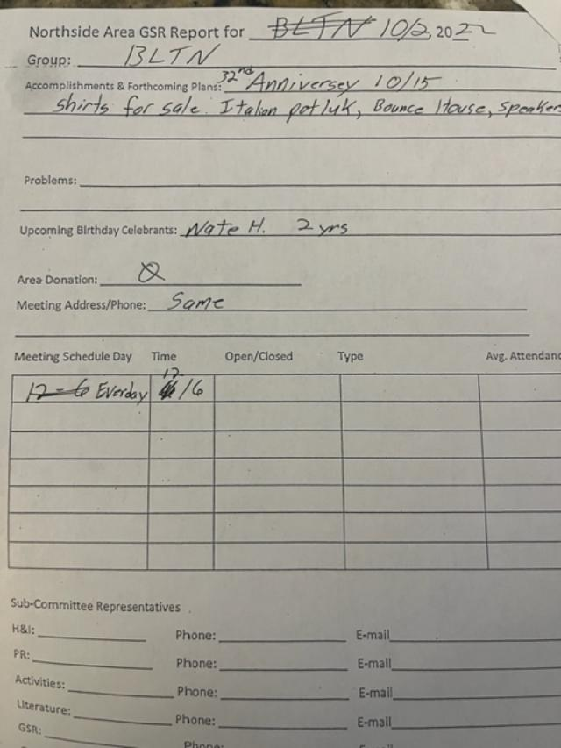
Happy Joyous and Free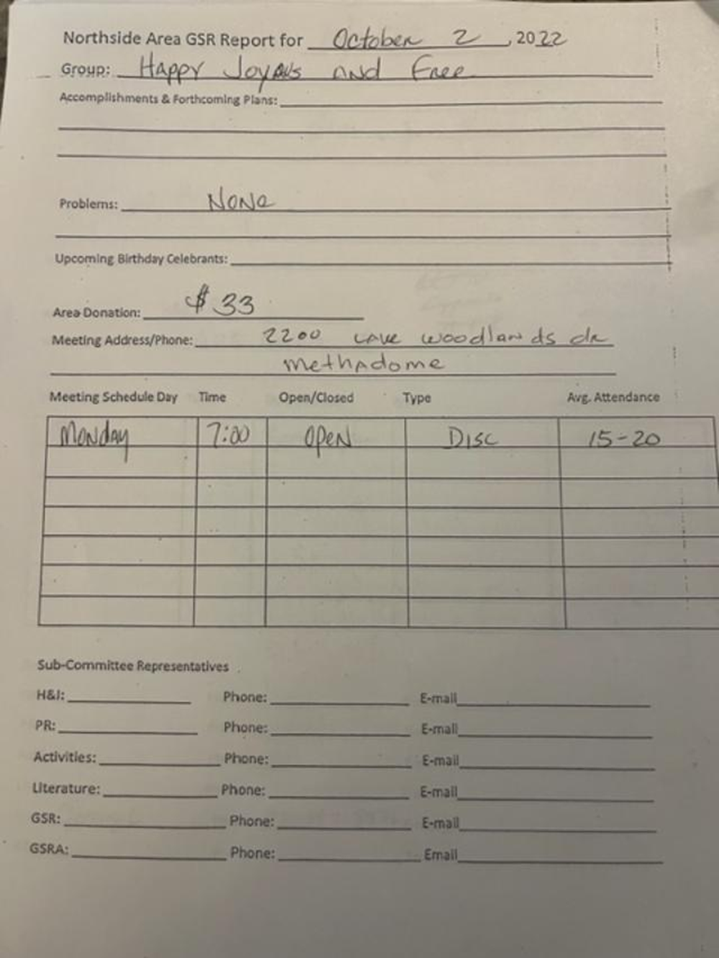

RIP
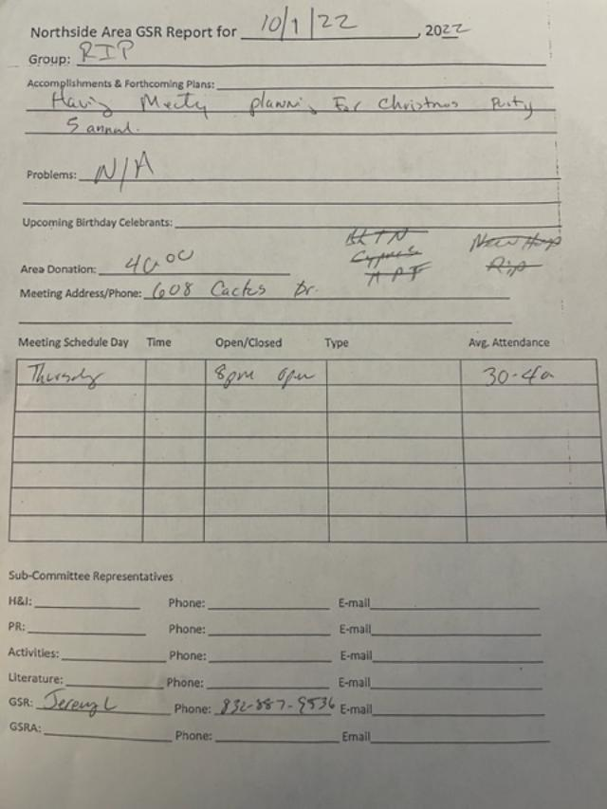

Show Up to Grow Up
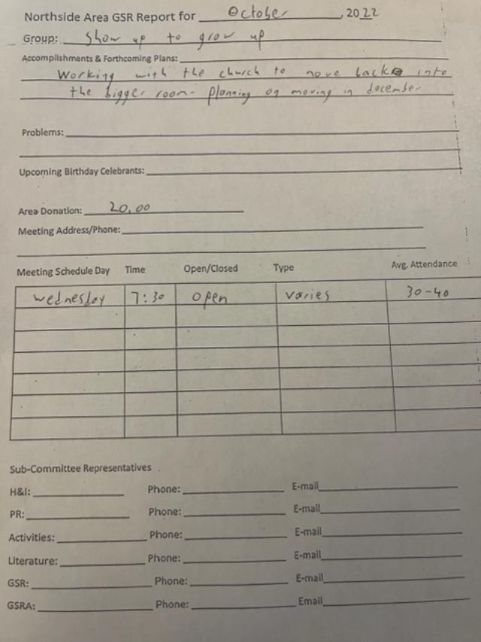

Unfinished business
Regional proposal to have only RCMs vote on proposals. Tabled
Sharing
How much to donate to TBRNA and World.
Shared about Gratitude Feast. Looks like it will be Nov 12 or 19. Jeremy will check with Conroe Club.
We didn’t get info from Glenna regarding reserving spots for 2023 FBTL. Need to get on that NOW.
Talked again about Loans taken by NAWS.
Larry pointed out that NAWS money comes mostly from book sales. They should stop taking donations.
Debbie points out that 20% from donations is still a lot.
Vicki says that NAWS is supposed to answer to groups. More transparency needed.
Robert says we are responsible to the addicts who contribute for where their money goes. Wer have transparent accounting, why don’t they?
New Business
Larry proposed we create subcommittee budgets. Accepted
H&I – 1000
PR – 500
Activities - 500

Elections
1 open positions – Literature Review
Next ASC NOV 6, 2022

Recorded to the best of my ability.

Scott Caggiano
NASCONA Recorder

All bank statements and spreadsheets are available for review at anyone’s request.

