NASCONA ASC September 11, 2022

Jeremy opened meeting with Serenity Prayer
Sean read 12 Traditions
Robert read 12 Concepts
Jeremy read purpose of ASC
Jeremy read Service Prayer
Scott called role of Groups
Groups present:
BLTN
Cypress
Happy, Joyous and Free
New Hope
RIP
Show Up and Grow Up

Scott called role of Trusted Servants
Trusted Servants present:
Facilitator – Jeremy
Co-Facilitator - Samantha
Co-Treasurer - Vicki
Recorder – Scott
RCM1 – Shawn
RCM2 – Paul
H&I - Robert

REPORTS
Scott read Recorders report – see Aug 2022 ASC Minutes
Treasurer Report – Debbie
Treasurer Report
September 11, 2022 (balances as of September 5, 2022)

Bank balance: $7,540.51
Prudent Reserve: ($900.00)
FBTL: [$1,500.00]

BALANCE: $5,140.51

Checks not cleared:
None – all have cleared

Deposits: $99.50
$0 (Square)
$20.00 (Venmo)

Deposits not credited: N/A

WORKING BALANCE: $5,140.51 [EVERYTHING BALANCES]

Hello everyone!
Sorry I am unable to attend today’s ASC. Our very competent co-Treasurer will be handling everything 😊

There are two issues we need to address:

- When I made the deposit last month, the bank teller brought it to my attention that checks are being made out to NASCONA, but our bank account says “Northside Area of Narcotics Anonymous.” This was my error. When I obtained the Federal Tax ID, that is the name I used. I am sorry.

I can try and correct the issue with the Feds, but I don’t know how long that will take. The teller did not want to deposit the check, but then acquiesced. Please let me know how you want to proceed.

- Our quarterly payments are due to TBRNA and World, per our policy (Article VI, Section A(9)).

I previously forwarded the response from World regarding the loan issue.

If the Area wants to still withhold funds from World, that would be a policy change that needs to go back to the groups.

I am sure it is not shocking, but I am against withholding funds from World.

RCM – Sean
RSC Meeting report
The TBRCNA audit was not performed according to policy due to scheduling issues. An audit was performed directly following the TBRCNA 22 convention. A proposal to accept the audit as performed was presented and passed by consensus.
I asked for more information about the PPP loans that were taken by NAWS. Reuben P read what he received from via email from a NAWS representative. The first PPP loan was for $600k, 83% of which was forgiven under the criteria of the loan stipulations. The remainder has already been repaid. An EIP loan for $150k was received and is being repaid on a 30yr note. A second round PPP loan was secured for $517k. Still waiting to see what portion will be forgiven, but it is expected that the same percentage will be forgiven per the identical criteria.

TBRCNA 2023 to be held in Beaumont February 24th-26th. As of the RSC only 6 rooms of the minimum 140 needed for contract fulfillment have been booked. Please put out the information to ALL. The 140 minimum rooms must be filled by January 31st!

Items to be voted on and returned to next RSC. More information needed. Will revisit before next Area Meeting in October.
Proposal – Financial Policy 7.1 Discussion: How much are we going to spend per quarter?
Proposal goes back to the Areas.
Discussion on this current Regional Delegate Team or the new one at the Regional Assembly covering
the CAR/CAT in one day. This will not happen in one day. Need two days. Saturday will be elections
and Sunday the CAR/CAT workshop or CAR/CAT and elections.
Proposal – that only RCMs 1 &2 vote at Region so that the Group Conscience on any business matter
is carried. Proposal goes back to the Areas.

Sean H.
RCM1
TBRNA RSC Record
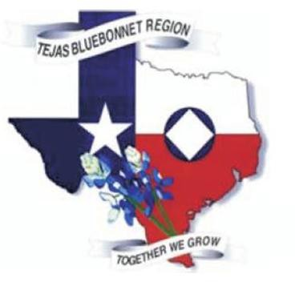
TBRNA Summer Regional Service Conference – August 13, 2022 – Hybrid Meeting Fall Quarter TBRSC will be a hybrid meeting on November 12, 2022

The Record

Meeting opened by Michael C. at 9:00am with a moment of silence. Twelve Traditions – Kent L
Twelve Concepts for NA Service – Monica Service Work Prayer – Esteban R..
New Participants: None

Attendance Servants
Facilitator | Michael C. | Present
Co-Facilitator | Chris H. | Present
Recorder | Esteban R. | Present
Treasurer | Kent L. | Present
Co-Treasurer | Tom K. | Present
Regional Delegate | Steven P. | Present
Regional Delegate Alternate | Ruben P. | Present
Adopt an Inmate Facilitator | Herb M. | Present
Convention 2023 Facilitator | Vyki D. | Present
Convention Advisory Committee Member | Michael S. | Present
Convention Advisory Committee Member | Allen E.
Convention Advisory Committee Member | Lucy V.
Convention Advisory Committee Member | Susen GB
Convention Advisory Committee Member | Gilbert L. | Present
Hospitals & Institutions Facilitator | Richard T. | Present
Internet Technology Facilitator | Steve S. | Present
Literature Review Facilitator | Lynn S. | Present
Policy Facilitator | Megan H. | Present
Public Relations Facilitator | Paul S. | Present
Service Pool Facilitator | Michael S. | Present

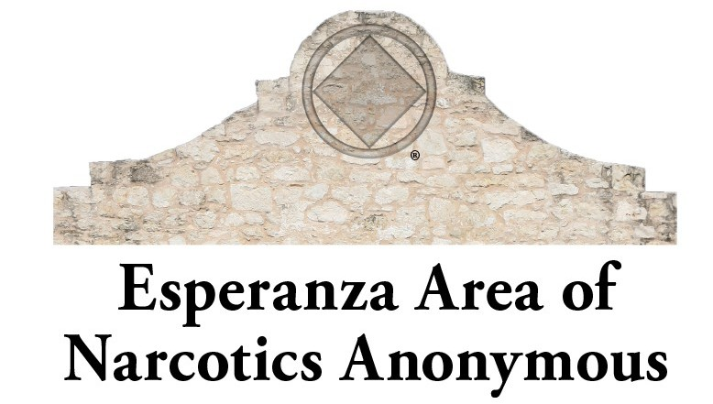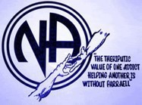Attendance Area Representatives

Brazos Valley Area
Brazos Valley Area
Central Texas Area | Sean FO | Present
Central Texas Area | Cleto M. | Present
Coastal Bend Area | Tom M. | Present
Coastal Bend Area
Esperanza Area | Jesse D. | Present
Esperanza Area | Gary L. | Present
Freedom Area | Chris C. | Present
Freedom Area | Steven P. | Present
Hill Country Area | Robyn K. | Present
Hill Country Area | Shan O.
Houston Area | Sarah H. | Present
Houston Area | Hurshell C.
Northside Area | Sean H. | Present
Northside Area | Paul C.
Rio Grande Valley Area | Rebecca L. | Present
Rio Grande Valley Area | Tony | Present
Southeast Texas Area | Micah J. | Present
Southeast Texas Area | Tristan
Texas Tri-County Area | Vic G. | Present
Texas Tri-County Area | Amy G.

Elections:
(8.4 Policy) TBRCNA 2024 Facilitator – Tom M. – Consensus CAC Members – 0
TBRCNA 24 Treasurer – Donna Mc – Consensus TBRCNA 24 Alt Treasurer – Josette Mc – Consensus

Old Business:
Convention Advisory Committee Policy – Consensus Transitional Discussion on CAC positions – Steve S.

Regional Delegate – Steven P.
I begin my report with two questions. Does the Region extend the service cycle for the RD team to match the actual cycle of the WSC? If so, does that change affect the service cycle of the current RD team, or the next RD team? Having the answers will help me to better plan for the Regional Assembly in March. Plans for the Regional Assembly are in process, and more will be revealed.
This past quarter the RD team attended the conference participant’s webinars. The next conference participant’s webinar will be in one week. Several items caught my attention. A service committee had a couple of hundred magnetic stickers printed with the QR code to their phone line. (The magnetic stickers were approximately 2-3” in diameter.) They then went to restaurants, bars and other establishments putting the magnetic signs on the inside of toilet stall doors. They also stuck the magnets up in public places like bus stations, bus stop shelters, train stops, etc. (Because these were magnetic no damage was done to property, so no complaints from proprietors or managers.) They reported a significant jump in the number of calls to their help line. Perhaps the Region, or some of the Areas might consider doing this. The QR code could also direct the person to their website.
I also attended several ASC’s virtually and in person. With the current high cost of travelling it is not possible to attend as many in person ASC’s as I would wish. I am bringing a proposal to the RSC today to modify Region policy to increase the amount Regional trusted servants can be reimbursed for traveling to Area Service Committee Meetings and other approved functions. See following pages for a copy of the current policy, and the proposal that I bring for consideration today. Ruben will present the RDA report. Thank you for allowing me to be of service.

*Proposal that Region change Financial Policy Section 7.1 will be under New Business

++Friendly reminder from this Recorder that as per our Policy, the RD Team has 30 minutes for their report and we are discussing a policy change proposal that should be brought up in New Business.

Regional Delegate Alternate – Ruben P.
Good Morning Everyone,
Hope all is well. I want to report that I attended the SZF in Denison, Texas on July 29th-31st. I have a few things to report. Let me begin with the following:
On the opening evening a PR presentation was conducted for the local fellowship. We had a good turn out and a mock presentation was done on how to do an NA meeting which was fun to watch and experience.
We also discussed where PR and Fellowship Development are headed to. There are two positions at the SZF. One is PR and the other is the Fellowship Development. They are here to assist the Fellowship in any capacity that is needed within our zone.
In parts of the country like Ohio and Arizona, a webinar was held that some of you may have attended and discussed, “How Do We Attract Members to Service?” I have attached two presentations to my report for your review and use. Links are contained within the attached documents.
More information can be found regarding this event at NA.org under the tab, “How Do We Attract Members to Service?”
We also discussed the work that is being done in the US as it pertains to these categories. I have three contacts from members who started this work which began with PR and virtual H&I.
The next item is that we will be hosting the SZF in January 27-29, 2023, which will be held in Austin, Texas. The agenda is still being created but we will be conducting a PR presentation to professionals on Friday morning at the host hotel in-person and virtually (hybrid). There will also be World participation because a CAR/CAT workshop will be held that weekend. We need the fellowship's participation and help from all area PR and those that can attend and participate at this event.

The next SZF winter meeting will be held on October 28-30, 2022, in Flowood, Mississippi. I still need a t-shirt design before this event.
The next item is we have moved the deadline for the survey we sent out regarding the US Zones Collaboration. The new deadline is December 13th. If your region has given you their vote, please turn it in as soon as possible.
The last thing I would like to report is that the Central Texas Area will be hosting the Regional World Unity Day, which is September 3, 2022, from 1-2.30pm. The location is 1513 E. Yeager Lane, Austin Texas. Immediately following is the CTA PR will hold a PR Presentation for the fellowship.
There are days when I get really excited about service. I have been getting in touch lately with this experience. It is that the fellowship is changing, and we have the opportunity to share the future of our fellowship. As I look around it seems that there is a new energy around the fellowship. My hope is that it continues to grow and brings along new members to this experience. That is my hope that service becomes attractive to others so that we can all share in this experience to help the still suffering addict. I will leave you with this from Aug. 8th SPAD: “I will try to accept all of me today. I am neither my strengths nor weakness. I am both. Broken in places but just enough to let the light shine in.”
I am turning in my receipts for reimbursement: registration $20.00, hotel $282.50, gas $100.00 which total $402.50.
+Attached to RDA's report were Power Point links and flyers gathered at the Zonal Forum that included Central Ohio Inmate Tablets, NA e-Lit, PR for H&I Jails & Prisons, Red River Region PR Workshop, How to Chair A Meeting, and a Recap Meeting #8 US Zones Action Plan Task Team.

***Subcommittee Breakout

Servant Reports

Facilitator – Michael C.
Welcome all and thank you Hill Country Area for hosting this quarterly RSC. Once again, we shall attempt a hybrid meeting, hopefully with better Wi-Fi / band access it will proceed more smoothly than last quarter. Thank you Esteban, the notated minutes clarified issues that we were having conducting business, dropped discussions, lack of vote on issues, and specific directions on my part as facilitator, all of which made for the recorded minutes a truer reflection of the meeting.
I also appreciated the bullet page of proposals the RCM’s needed to bring conscience back on and for me it outlined Old Business.
The proposed Agenda is based on the policy and minutes, if I have omitted anything or there is a scheduling issue, please help me with these concerns.
Upon further review of the limitations of the breakouts for subcommittees, the current system seems to accommodate most of the participants. If any subcommittee facilitator wants to schedule a virtual meeting at a different date or time, IT or the webmaster can assist in set-up.
Thank you to those who stepped up as others engaged in verbal assault/confrontation last quarter. My personal confrontation skill set is very limited to inappropriate engagement and internal shut down. I believe that the role as facilitator is in the organization and distribution of data. The policy says that as facilitator I should have no opinion or vote. Thus, in facilitating the balance is in the utilization of time and resources so that everyone’s point is allowed to be expressed, (group conscience) without unnecessary repetition or soap box grandstanding. The principles are clear and simple, and without
personalities. Of service.

Co-Facilitator – Chris H.
Greetings,
Thank you for allowing me the honor of serving this committee and by extension each of you, your areas, and the addicts we serve.
My duties are still light, and I have no RSC business to report. However, Tom has reached out to get me oriented to better help with Insurance certificate requests and email accounts.
I attended the May, June, and July Texas State Convention Advisory board Meetings. There were a few highlights that I wanted to make sure your areas know about.
The May meeting was held at the convention and a newsletter was distributed with a
breakdown of funds dispersal since the beginning. I gave my newsletter away without thinking about bringing it to this conference but I know many of you have seen that there has been a significant dispersal of funds across all of Texas for the last 20 years. The point is that the committee wishes to keep all of the member regions and areas aware of where the money goes.
The June meeting had one notable item. Since the Central Texas Area had expressed interest but
never bit for the 2023 convention. The advisory board made the decision to move ahead with Austin as the hosting city. The committee will following the model set by our own CAC and adding members from the advisory board to the convention committee to insure continuity in the future.
In that light, The July meeting also served as the TSCNA 20th Anniversary committee meeting. Many of the committee service positions were filled, but there is still a great need to fill the rest with members from around the state. Diversity is the goal, and that diversity extends to the effort to have the committee peopled from as many different areas, and regions as they can.
Lastly, I hope to see you at the World Unity Day Celebration. My own area will be hosting a local event including the world zoom.
I feel lucky to serve on a committee that so clearly holds our traditions first in service to our members. Thank you for your part in that, each of you. Yours, Chris H.

Treasurer – Kent L.
Good Morning, All:
As of the compiling of this report we have a working Balance of $11,113.12 - this is after deducting our Prudent Reserve of $4500.00. ($8113.12 if proposal of $7500.00 reserve is approved today).
We are still looking into the IRS filing of 990 returns. The latest printed out and in my files year is still 2013. We have sent in a request to get what copies of the years that they do have on file for us. At this time I am still waiting for correspondence back from them. I've have tried calling to no avail.
We (the designated servants) attempted to come together to "re audit" the TBRCNA account, unfortunately illness and timing of all parties involved did not work out yet.

Check list for Treasurer

All Donations Deposited
X
within 7 days

Sales Tax Reported/ Paid
X
(if Applicable)
X
Check Book Reconciled

Insurance Paid

(if Applicable)

Pay AAI Lit. Invoices

(if Applicable)

Southern Zonal Donation
X
(if Applicable)

Prepare RSC Report
X
include All

"Account Activity"
X

Donation Record
X

NAWS Contribution Receipt
X

Web File Receipt
X

Regional Insurance Receipt
X
(if Applicable)
Bank Statements
X

Checks to Naws
front & back

Quick Financial Glance (As reported before RSC)
Starting Balance from last RSC: | $17,228.06
All expenses paid out | $4,404.08
Total | $12,823.98
All Income Received | $2,789.14
Total | $15,613.12
Minus Our Prudent Reserve | $4,500.00
Current Starting Balance for this RSC | $11,113.12

This RSC expenses to pay out
SZF Qtr Donation | $
AAI mailbox | $
Websvc | $
Total expense to payout this RSC | $
NAWS Donation as approved @ RSC | $
Ending Balance | $ 11,983.96

424 | Bill Payout | 05/11/22 | HASO Inc AAI | -$185.40 | $17,228.06
425 | Deposit | 05/13/22 | RSC 7th Trad Collection | $53.00 | $17,281.06
426 | Deposit | 05/13/22 | James Mallard H&I rtn funds | $20.00 | $17,301.06
427 | Mbl Dep | 05/16/22 | BVANA chk 1312 addtl 7th | $471.00 | $17,772.06
428 | Mlb Dep | 05/16/22 | Paul Showery. rtn of funds PR | $150.00 | $17,922.06
429 | Chk 1553 | 05/14/22 | M Bridges gas reimb | -$69.80 | $17,852.26
430 | Mlb Dep | 05/19/22 | HCANA Chk 1218 | $30.37 | $17,882.63
431 | Bill Payout | 05/26/22 | NAWS Donation | -$2,521.63 | $15,361.00
432 | Bill Payout | 05/26/22 | Steven Primm reimb | -$300.00 | $15,061.00
433 | Bill Payout | 05/26/22 | SZF donation | -$300.00 | $14,761.00
434 | Zelle/Out | 05/31/22 | Esteban R reimb gas | -$62.00 | $14,699.00
435 | Chk 1554 | 05/28/2 Reimb2 | Ruben P | -$200.00 | $14,499.00
436 | Bill Payout | 06/06/22 | HASO | -$129.00 | $14,370.00
437 | Mbl Dep | 06/13/22 | Tx Unity Convention #2322 | $178.07 | $14,548.07
438 | Mbl Dep | 06/13/22 | HASCONA Chk 2834 | $66.39 | $14,614.46
439 | Mbl Dep | 07/06/22 | HASCONA Chk 2838 | $63.10 | $14,677.56
440 | Mbl Dep | 07/06/22 | HCANA Chk 1222 | $35.06 | $14,712.62
441 | Mbl Dep | 07/06/22 | SETANA Chk 1257 | $ | $14,743.28
442 | Web file | 07/22/22 | Tx Comptroller | -$52.00 | $14,691.28
443 | Bill Payout | 07/25/22 | HASO | -$325.10 | $14,366.18
444 | Stripe | 08/10/22 | EANA 773.81 Keep Clean20.20 | $751.09 | $15,117.27
445 | ACH | 08/11/22 | TX Tri County | $500.00 | $15,617.27
446 | Bill Payout | 08/12/22 | HASO | -$301.80 | $15,315.47
447 | Bill Payout | 08/12/22 | HASO | -$142.75 | $15,172.72
448 | Mbl Dep | 08/12/22 | HCANA Chk 1227 | $312.00 | $15,484.72
449 | Mbl Dep | 08/12/22 | HCANA Chk 1225 | $100.00 | $15,584.72,
450 | Mbl Dep | 08/12/22 | HCANA Chk 1224 | $28.40 | $15,613.12

Quick Financial Glance (As reported at the RSC)
Starting Balance from last RSC: $17,228.06 All expenses paid out: $ 4,404.08

Total: $12,823.98
All income received: $ 2,789.14
Total: $15,613.12 Minus our Prudent Reserve $7,500.00 Current Starting Balance for this RSC $8,113.12

This RSC expenses to payout
Donations Income | $7,330.90
SZF Quarter Donation | $30.00
M. Bridges | $62.59
Ruben P. | $402.50
Steven P. | $190.00
Paul S. PR Booth, IPs, supplies | $900.00
Websvc
Richard T. | $375.00
Total expenses to payout this RSC $(5,100.81)

Remaining Balance $13,213.93
NAWS donation as approved @RSC 8/13/22 $4,642.73

Ending Balance: $8,571.20
**Discussion on TBRCNA 23 Audit – consensus on not having to re-audit. Tom K. will assist Kent on filing 990 with the IRS.

Recorder – Esteban R.
Greetings all. The May Record was sent out and did anyone note any corrections that need to be made? Hopefully this RSC will run smoothly. Under New Business, I will be submitting a proposal to amend/change policy under 7. FINANCIAL 7.10.5.

Convention Advisory Committee – Michael S.
Hello Conference,
Presently we are in negotiation with the Marriott Westchase Houston for TBRCNA 25. Two other hotels, the Marriott North and the Omni, are in the chase.
The dates for the Convention are Feb. 14-16, 2025 Valentine's Day weekend. Bring your roses!
I will be attending HACNA 14 at the Marriott Westchase Sept. 16-18 and meet with the Sales Mgr. Regina, to continue our negotiations.
Personal note- Registration and banquet tickets fully support the Convention and the costs associated with the hotel- it is not for any profit.
By the next RSC in November, I will have a contract in hand if not before. I will also be in talks with the other hotels and may even visit them, I may present gas receipts.
One more thing, is that, Hotels have gotten very proud of their Convention Centers since the pandemic and so, costs have gone up significantly. I will do my best.

TBRCNA 23 – Vykie D.
Pre-Registrations: 140 Hotel Rooms Booked (as of July): 6
Hello Family, I think everything is coming along nicely for TBRCNA 23. I am a little worried about the hotel rooms but I do know that us addicts like to do things last minute and a lot of other conventions have been happening so I’m hoping room reservations will increase soon. Please be sure to announce to your groups that we have a limited amount of rooms (approximately 140) and the deadline for us to meet our room block is January 31, 2022.
I know that seems like a long ways away but booking early helps us project our attendance and keeps the hotel confident in our convention.
Our full pre-reg package is now live on the site and includes the following: • Pre-Registration $20 • Pre-reg t-shirts $20 • Cajun/Mexican Buffet - $40 (vegetarian option available) • Comedy Show, Comedian Bob Perkell - $20 • Newcomer Donation Total cost of pre-registration package is $100.

We have sold out of most of the 2022 convention merchandise and almost all of our first edition t- shirts. The SETANA Crawfish Boil was a huge success and SETANA donated a total of $1,116.31 from proceeds of the Crawfish Boil to TBRCNA 23.
During our last meeting we did a walk-thru of the hotel and have a pretty good idea of what we are going to put where. I’ve also attended programming meetings and I feel that we are going to have an awesome program for the attendees and most importantly, newcomers. We also have some great ideas for merchandise and registration bag items.
Lastly, we had the hotel revise the contracts to include the correct dates (change 2022 dates to 2023) and change the banquet meal from a plated dinner to the a buffet. It is my understanding that the TBRCNA Facilitator needs to sign this and I will get with him after this meeting to do so.
Once again, please BLAST pre-registration and hotel reservations to your groups and areas.
I’ve attached the full flyer to my report email for distribution to groups throughout the region. Also please encourage everyone to fill out our survey for suggestions! https://forms.gle/2k9m8d4odGox1XYNA
Please see below for our latest Treasurer’s report from our last meeting on July 23, 2022. Our next meeting is August 27, 2022 at 1 PM at the Elegante and on Zoom.
*A TBRCNA Registration Flyer was attached to this report.

Service Pool – Michael S.
Hello Conference,
I am grateful for the experience, strength and hope in service as your Service Pool Facilitator.
Since our last meeting I have been working with Ruben P, Paul S and Tom K. These are our findings: There is a Service Resume online at tbrna.org. Log in or create user to access resume form under Service. Click on Service and drop down to Service Resume, click. Then create your resume then click on Submit Resume.
There is also access by using the QR code included in this report which will take you to the Service Resume site, then Log In and fill out the resume. So now there is access by laptop, desktop or mobile. Information requested is Personal Information, Recovery, Service History, and Relevant Education, Occupation, and Life Experience. Then click Submit Resume. We can also log in to edit our resumes. There will be a link provided to me so that I can access the resumes to view and host open positions, a URL, so I that know when a resume has been submitted.
I will also send out Service Resume Forms, an URL and the QR code to the Fellowship and candidates regarding open positions. RCMs take this information to your Areas, please.
My number and email are included below, feel free to contact me. In Service

*** 40 Minute Break

Area Reports:

Brazos Valley Area – Michael C. – No representation from this Area.

Central Texas Area – Sean Fo., Cleto M. – Dear TBRNA: Hello Region! Central Texas is moving right along. Our area policy subcommittee is updating the policy, and it is going great! The rough draft is done, and there will be a workshop for the rough draft. Public Relations subcommittee has put together a Forever Schedule. This is a meeting schedule with a QR code to scan that directs to the CTANA meeting list within the website, some NA literature within the schedule, and a place for numbers on the back. Hospitals and Institutions are doing well. There are many new facilities opening their doors to us, and we are bringing the message of hope. Activities has been trucking right along, bringing us fun in recovery, and showing the newcomer how to have fun in recovery. Also, I heard that

our regional donation check was past the deposit date of the check. Then, I heard at area that our treasurer has not been sending checks, for lack of knowledge being passed down from past treasurer. Our area is working on a procedural policy to pass down from treasurer to treasurer. This was mainly from not having a vice treasurer. And, we will be working on this for the months to come. I am bringing a check for the past quarters to region for deposit. The check is for 1423.95. Our area has come to a consensus on all of the regional proposals. Cleto and I will our vote to the table. “A Guide to Local Services” The love that connects one person to another to the next, the selfless services that feeds and houses and clothes and warms and nurtures humankind – of that love, of that selfless service we had no part. That’s why it’s such a privilege in our recovery to be able to serve others, for we come to know ourselves only in looking beyond ourselves and we keep what we have by giving it away. By empathizing with other members, by learning to appreciate their needs, by placing them ahead of our own – by these things we learn to love others, and in so doing we learn to love ourselves. Sincerely

Coastal Bend Area – Tom M. –
Dear Regional , I’m here to report that we had a very successful Recovery By The Sea ... we had people from all over the us. We are still working on closing the books for RBS 38. Next region I will be bringing a donation once we get everything done. We have 63 meetings weekly zoom and in person Our votes for the four Proposals are yes to all.
RCM1 Bill H. regretfully had to step down as RCM1.
CBANA is looking forward to starting the 2024 Convention Committee.Thank you for letting me be of service

Esperanza Area – Gary L., Jesse D. – Esperanza Area TBRNA Joint RCM Report August 13, 2022. Good morning family I’m a recovering addict named Gary L. RCM II. The Esperanza Area has the following positions filled.
Chair Esteban R Vice Chair Deb G Secretary Eliza G
Alternate Secretary ~ Open ~ Treasurer Alia C
Alternate Treasurer ~Open~
Regional Committee Member I Jesse D Regional Committee Member II Gary L. Activities ~ Lupita S.
Esperanza Area Convention V III-Chair Abdul R Frolic in the Woods 2022 Gilbert L
Hospitals & Institutions Hunter W Internet Technology Leonora Y Literature Bank Delmar R. Literature Review ~
Newsletter -Jerry D Outreach ~ Laura W.~ Phone Line ~ Liz S Policy Satch G
Public Information Roger S. Sr
Esperanza Area Service Committee Meeting (ASC) next meeting date will be on Sunday August 21, 2022 we meet the third Sunday of every month) at 11AM @ 758 Donaldson, San Antonio, Texas. Our Area took up the motion to increase Regions prudent reserve so we can send both RD's to the WSC and it was passed.

Upcoming events in our area are as follow:
1. Frolic in The Woods is having a support function for our upcoming event "FROLIC FUNDAY”: August 20, 2022, 12:00 pm – 4:00 pm. at Cassiano Park, San Antonio, TX
- Road to Recovery is having their Anniversary August 20th all day,
- EACNA VIII is having an event support function 9/3/2022 from 2-8pm
- Frolic in the woods will be held at Garner State Park September 30- October 2, 2022 Thank you.

Freedom Area – Chris C., Steven P. – Hi all!
We welcomed a new group to the Freedom Area - We Do Recover. Average meeting attendance is 12 to
15. The Freedom Area is doing well. We are approving the increase prudent reserve and also the new convention subcommittee guidelines. Light and love to all
** Discussion on Metro Area geographical representation – “Westside Co-op”

Hill Country Area – Robyn – The Hill Country Area has 11 meetings per week serving the Area from Buda to Schertz and Johnson City. We had a successful activity – Recovery On A River (ROAR).
About 100 people enjoyed the bright sun and the cold river water. Two speakers brought the message. The groups are growing with many newcomers and returning addicts. We are following the Traditions. We are excited to host The Regional Service Conference. Enjoy the night float!

Houston Area – Sarah H., Hurshell C. – Salutations, We are looking forward to seeing many of you tomorrow in San Marcos. Since we last reported HASCONA has been steadily preparing for our bi- annual convention (HACNA) that will be held the weekend of Sept 16-18. We are hoping to see many of you there as we gather to celebrate our recovery. We want to give a shout out to CBANA who hosted RBS last month. What a great turn out and great speakers. NA truly is a love story. H&I has picked up 2 new facilities and is planning another H&I event in October with a book drive. Alive and Kicking is having their annual celebration in October to celebrate 49 years of carrying the message to the still suffering addict.
Contributions: Regional donations since March $194.32 NAWS donation is $97.17 since March
I thank you all for your service to this fellowship and for sharing your experience strength and hope. For more information about HASCONA please visit our website at https://hascona.com/
In loving service,

Rio Grand Valley Area – Rebecca , Tony – Good Morning TBRNA,
Our area has not been growing so fast in numbers, as we had hoped, but the willingness in our members has grown. We are able to see the fire in those newcomers who see us having fun, having responsibility, and being close that they are already showing up to be a part of our event set ups and clean ups. Our newcomers are excited to know that they need to be at our meetings because “I gotta take out the trash” or “I gotta get there early to make sure there's coffee.” The biggest lesson our area has learned this quarter? Giving our new members responsibilities, telling them we missed them at the last meeting, and celebrating their milestones as a family has shown us that our retention rate is better. Here are our new trusted servant positions:
H&I Chair -Tony C. PR Chair - Christina R. Activities Chair - Aaron J. Next position to be voted on: Literature Chair
Many of our members are wearing more than one hat so we have to be very vigilant on keeping checks and balances. One of the biggest challenges is that our members have shown great willingness, but it is their first time being in that position. It sometimes feels like the blind leading the blind, since I am learning and teaching at the same time.
I know that any area who has experience with H&I, PR, and Activities I welcome you to please email us at rgvareaofna@gmail.com or text me 956-929-2142 your name, area, and area of experience

because we could really use what would essentially be a phone list of guidance for our committee members to be able to reach out to.
Let's talk about PR. Our current PR chair Christina is one of those people whose great willingness lights a fire under all of us. She is constantly printing flyers, making appointments, and reaching out and trying to have tabling events. Christina has done a great job of showing the professionals, homeless shelters, food banks, and doctors offices to know we are here.

Currently she is looking for PR guidance on previously made business cards, cold emails sent to companies, and some examples on meeting and area flyers. Please email any examples to rgvareaofna@gmail.com.
Now for H&I. Our H&I chair Tony and our PR chair have met with Tropical and have finally gotten a start on making a contract with a facility to meet twice a month, adolescence, boys and girls separate meeting. We are trying to get a contract with Tropical. If anyone has any ESH on working with adolescence or doing two meetings at the same time male and female or working with Tropical please email rgvareaofna@gmail.com.
Here is our greatest news! We have officially decided to reclaim what was once Serenity In the Sand, and rename it, but the idea will stay. A big convention in a hotel by the beach in September. Starting next month we plan to meet on the last Saturday of every month. We want to have a fundraising event similar to Tiki Torch meetings that CBANA does for RBS. This first meeting in September will be a trial and error mostly area meeting and after that we invite you to make plans and join us and anybody who has willingness to share or knows great speakers that would help us, please let us know.
Finally, we would like guidance on the quarterly or yearly budgets that yall have for Activities, PR, and H&I. Guidance on how those funds are allocated. When does activities budget end and areas start for area events?
At our next ASC Meeting, we will address Regional donation amount for groups to vote on. ILS, Tony We are still having an extremely difficult time getting a bank account, due to our small funds since most accounts charge a fee for small accounts. Even with guidance from world, region, and other treasures, we have been denied a bank account due to them not counting our policy as by-laws and our area meeting minutes are “Minutes” or issues with our monetary amount. Please if you have any ESH on getting a bank account for an area that normally has small funds and does not charge a fee please email rgvareaofna@gmail.com.

Thank y'all for being here for us as we work through our growing pains and for sharing your ESH with us.

Northside Area – Sean H. – **This Recorder reached out to Sean to let him know that the report he sent in was the Old Business Proposals and have not received a reply. My notes at this RSC for this Area has that NAWS is no longer funding RD's travel and that Regions are funding their Rds. PPP was also discussed.

Southeast Texas Area – Micah J. – We have 8 groups and 40 meetings per week in the Southeast Texas Area. Wings of
Freedom in Nederland, CCC, Subject to Change and Just for Today in Beaumont. New Life in Rose City, New Attitudes in Jasper,and Oasis in Port Arthur. For the most up to date SETANA meeting schedule, please visit www.setana.org
H&I
Southeast Texas Area H&I is bringing meetings to The Melton Center( currently on Covid Lockdown) , Franklin North Women’s Treatment, and most recently Franklin’s South Men’s Treatment Center.

Trusted Servant Positions
- Facilitator : Paulina G
- RCM : Micah J.
- Alternate RCM : Tristian A.
- Treasurer : Cindy B.
- Alternate Treasurer : Mandy
- Secretary : Tresa C.
- H&I : Bryan A.
- PR : Dave H.
- Activities : Philip S.
- Outreach : Bert
- Co - Outreach : Twana S.

Area Concerns
Upcoming Events
The New Life Canoe Trip has been canceled and probably won’t happen due to water levels at Village Creek. New Life is having a speaker meeting Saturday August 20th @ 8pm. Teresa B. from Wings of Freedom
CCC has a speaker meeting Tuesday August 20th @ 8pm Paulina G. from Wings of Freedom.
CCC Beach Bash is October 28th through 30th
SETANA will be hosting the RCS on Saturday November 12th. We will also have our Unity Dinner that same evening ( tentatively at the same venue) so any participants
from the RCS will be more than welcome to stay and be a part of! We hope to see you there!

*** Discussion on changing RSC rotation. Consensus to leave rotation as is due to upcoming Convention events already scheduled.

Texas Tri-County Area – Vic G – I'm Vic G. RCM 1 from the Tri-County area and my wife, Amy G. is RCM 2. It feels so good to finally be able to make a Regional meeting in person once agaim. First thing I would like to announce is that the Tri County Convention will be held on Nov. 18-20th. It will be at the Hilton Nasa Clear Lake, 3000 East NASA Pkwy. Houston Texas 77058
Our Area consists of 14 groups and our donation this quarter is $500 -- bringing our total for the year thus far to $13,500.
Our H&I serves 7 facilities at this time which consist of treatment centers, county jails, and TDCJ. Our vote to change the RD team cycle from 2 to 3 years passed.
Our vote to increase our prudent reserve did pass. The vote to increase 6the RD budget did not pass.
The vote also passed to allow AAI to send approved NA literature.

Subcommittee Reports

Adopt An Inmate – Herb M – Adopt An Inmate (AAI) has been busy this quarter sending out 40 Basic Texts, 3 Just for Today Daily Meditations, 3 Living Clean Books, and 2 Step Working Guides. I have been assured by Ron S. at HASO that all requests have been mailed out. Kent L. our Treasurer has confirmed that all invoices have been paid.
Our quarterly budget is $600. The AAI orders this quarter totaled $769.60. Does this body want us to continue sending addicts literature other than the Basic Text when requested? Yours in Service
***Discussion on AAI Flyer

Hospitals & Institutions – Richard T. – Good morning Family, this is my H&I report for Last Quarter. I have been working with HACNA and TTCCANA to help then with their H&I slots. I’ve been trying to get in contact with the TDCJ chaplain about an option for the behind the walls slot at TTCCNA in November. If anyone has any experience with this process, please feel free to reach out to me. I need all the help I can get due to covid it’s been a hard process. I was also invited to participate in the learning day held by RGV in July. I was asked to help provide a case of basic text for their book drive, so I purchased a case from our area Literature Chair and took them to sell down at the event. 16 books were sold at $10 each which was done at a loss in order to make it easier to get the books in the hands of new members in that area. I had reached out to the previous chair about my budget because the request was made before I had a chance to make it to my first official regional meeting and request more guidance in this area. I am asking to be reimbursed for the loss of funds at that event if that is possible. I would like to purchase another case to have on hand this quarter in the event an area reaches out for my support for any H&I book drive. I’m honored to be of service and to be allowed to learn what my position can do to better serve NA as a whole… thank you for my recovery

Internet Technology – Steve S. – Hey Everyone, Not much to report on the ADHOC. IT has been just added events when needed.
If your ASC web person does not have access to the BMLT to update their meetings let me know and I will help.
If any of the webmasters need help just let me know also.
***Sample of T-shirt for SZF submitted with this report. BMLT and automatic updates.

Literature Review – Lynn S. – Hello from Literature Review!
The Spiritual Principle a Day Meditation book is available as an email subscription. Go to na.org/subscribe if you are interested. The book itself is expected to be published later this year. There are two opportunities for you to give input on literature projects. They can both be accessed at na.org/survey.
The Loner IP is being revised and you can give input until August 31, 2022.
The second project is a survey on drug replacement therapy/medication assisted treatment (DRT/MAT) as it relates to NA. A motion was passed at the World Service Conference (WSC) 2018 for a project plan to create a piece of literature on this topic and at WSC 2020 to approve a Fellowship survey. If you have input on what you would like to see in a piece of NA literature on DRT/MAT please fill out the survey.
Literature Review is always available for workshops.
Please contact me if you need more information or have questions. In Loving Service

Public Relations – Paul S. – COMMENTS, PROBLEMS, QUESTIONS: I have been working on a Dynamic QR-Code program which allows me to create QR-Codes that can be tracked. We are able to know how many clicks a particular code gets. This will allow us to know how effective our getting the word out is. I can create up to 1000 different codes for various direct links to: functions, meeting schedules, websites and subcommittees. Please see handouts at RSC.
I am bringing a check for $100 for my reimbursement to Region for an event that I was unable to host 3 years ago.
ACCOMPLISHMENTS, GOALS: Coordinate with all Area subcommittees to see if they are interested in Dynamic QR-Codes. TBRNA PR booth display will be at: Miracles & Solutions Event, possibly HACNA & TTCANA Conventions plus EACNA Convention.
ITEMIZED MONTHLY EXPENSES: I need to get all supplies for PR booth. PROPOSALS FOR TBRNA: Please see handouts for items needed for PR display.
***Attached to this report were samples of QR-Codes for some Areas.

Proposal: By Esperanza Area that RSC fund PR $900 to re-stock literature, a new IP Rack and a new Tri-fold Display Case. Consensus

Policy – Megan H. – Hello family,
Per discussion during the RSC meeting in May, I have added AAI on May RSC conference planning (section 8) for subcommittee elections. It’s not a policy change, but needed to be included for consistency and accuracy. I met with Chris C. (former policy chair) on 6/25/22 via Zoom to address discrepancies & get clarification. I am attaching the updated policy and it has been uploaded to the TBRNA website. Thank you for letting me be of service,
***Please disregard the attachment on my previous email, I made an error in the formatting of the policy document. It has been corrected and is attached to this email as well as uploaded onto the website.
***Discussion on updating Policy and Consensus on Policy Housekeeping.

Old Business
Convention Advisory Committee Policy – Consensus
Proposal Policy change RD Team cycle from 2 years to 3 years to match WSC cycle. Consensus

Proposal Policy change RD Team Budget from $2500 to $6000. Consensus

Proposal Policy change Prudent Reserve from $4500 to $7500. Consensus

Proposal That we allow AAI to send one (1) piece of literature per request. Consensus

TBRCNA 22 Final Audit – Already discussed; wasn't done as per policy but everything was in order.

Proposal That an Ad Hoc committee research a “Sponsorship Behind the Walls” between AAI & PR

Consensus Ad Hoc will consist of Kent L., Jesse D., and Herb M.

Proposal To continue having Zoom/virtual RSC meetings indefinitely. Proposal rescinded.

New Business
Proposal – Financial Policy 7.1 Discussion: How much are we going to spend per quarter?

Proposal goes back to the Areas.
Discussion on this current Regional Delegate Team or the new one at the Regional Assembly covering the CAR/CAT in one day. This will not happen in one day. Need two days. Saturday will be elections and Sunday the CAR/CAT workshop or CAR/CAT and elections.

Proposal – that only RCMs 1 &2 vote at Region so that the Group Conscience on any business matter is carried. Proposal goes back to the Areas.

Treasurer's Update – See Treasurer's report. NAWS Donation – See Treasurer's report.
Announcements – Next RSC November 12, 2022 Adjourned @4:10pm

The Record by Esteban R.

RD Proposal to TBRNA

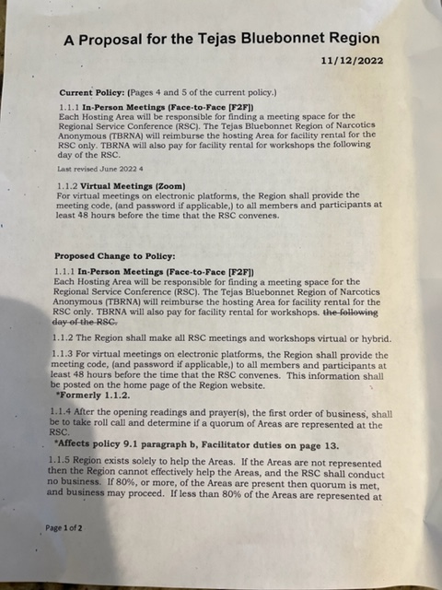

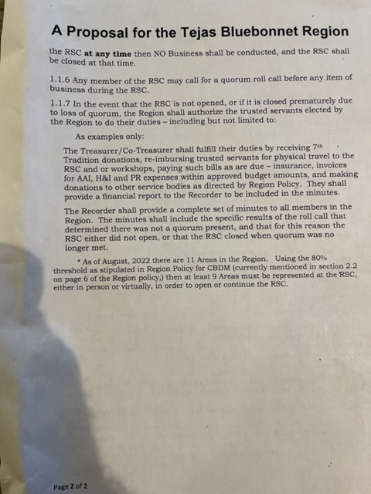

H&I – Robert
Held H&I subcommittee meeting before ASC. Meetings continue at Holliday, Luther and Huntsville Units. Adding Mark to gate list at Luther. Distributing literature.

Co-Facilitator – Samantha
No report this month

Group Reports
BLTN
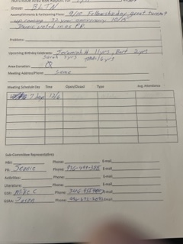
Cypress Group
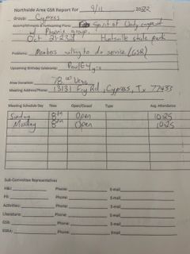
Happy, Joyous and Free
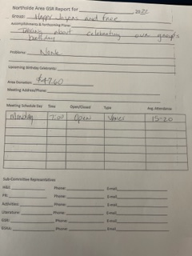
New Hope
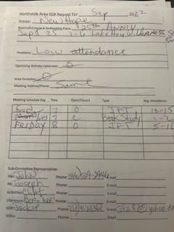
RIP
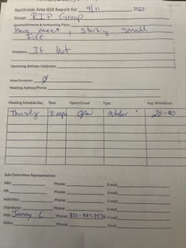
Show Up to Grow Up
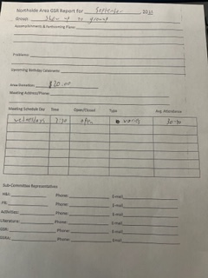

Unfinished business
none
Sharing
Steve (RD) shared about the proposal that was brought back to the Areas and Groups from TBRNA. The proposal is for limiting voting at RSC to RCMs only. There was much discussion both for and against the proposal. Steve suggested amendments to the proposal or changing it altogether to require a quorum of Areas to ensure that representation from the Areas outweighs the RSC Trusted Servants. Or adding that any two Areas can ask for any proposal to be sent back to Areas. There may be further discussion on this, but for now, we sent it back to Groups and we will see what they say at next ASC.
We addressed the Treasurers issues in the Treasurer’s Report:
- Regarding any name changes, we have tasked Debbie and Vicki with determining what is the best course for the Area and implementing that.
- Regarding donations to Region and World, Article VI, Section A(9) states,
“9. World and Region donations shall be made on a quarterly basis, amount determined by consensus of trusted servants.”
It was discussed and decided that the Area does not have to vote to “withhold” funds, we can simply, by consensus, determine the amount to be zero. This would negate the need for any policy change.

Mike asked about the progress of 501 (c) 3 for the Area and we asked Vicki to keep working on it.
New Business
TBRNA proposal on RCM only vote sent to Groups.

Elections
1 open positions – Literature Review
Next ASC OCT 2, 2022

Recorded to the best of my ability.

Scott Caggiano
NASCONA Recorder

All bank statements and spreadsheets are available for review at anyone’s request.

