NASCONA ASC July 10, 2022

Jeremy opened meeting with Serenity Prayer
Groups present:
BLTN
Cypress Group
Happy, Joyous and Free
New Hope
RIP
Show Up and Grow Up

Vicki called role of Trusted Servants
Trusted Servants present:
Facilitator - Jeremy
Treasurer – Debbie
Co-Treasurer - Vicki
H&I - Robert
PR - Larry
RCM1 – Shawn
RCM2 - Paul

REPORTS

Treasurer Report – Debbie
Treasurer Report
July 10, 2022 (balances as of July 3, 2022)

Bank balance: $8,043.33
Prudent Reserve: ($900.00)
FBTL: [$4,581.86]

BALANCE: $2,561.47

Checks not cleared:
None – all have cleared

Deposits: $2,266.33 (cash) – included $1000 from Crawfish Boil & $968 from Woodna
$0 (Square)
$60.00 (Venmo)

Deposits not credited: N/A

WORKING BALANCE: $2,561.47 [EVERYTHING BALANCES]

7th Tradition $20

RCM – Sean
No meeting in 6 weeks. TBRNA website: Spiritual Principle a Day available to download. Book coming soon .
RCM2 – Paul

H&I – Robert
Has a few new members. Presentation at veterans place. Need to set up H&I meeting. Date and time to come.

PR- Larry
Good morning all.

In preparation for the poster drive for New Hope I ordered:

500 NA business cards - 45.00

150 8.5'' x 11.5'' flyers - 15.00

200 Meeting schedules - 43.00

10 Large posters, 17'' x 21'' - 11.50

For a total cost of 123.95 including tax.

For Hot dogs, drinks and fixings - 63.06, New Hope donated 23.06 to this cost.

Total cost - 186.98 for the poster drive.

I ordered an additional 200 schedules for the area, and we used about 75 of those for the poster drive too.

Cost of the 200 Area schedules is - 46.55

I have 20.00 to return to area.

We distributed about 350 cards, 275 meeting schedules, and 100 flyers.

The large posters along with the remaining printed goods were left with the New Hope group for future use.

Because the event was on Saturday we were unable to go to the courts, rehabs, police stations and other public institutions, so there is more work to do that must be done during normal business hours.
I will be working on this and reaching out to a few members that might be available to help during normal business hours.

The poster drive event was a great success.

We had 12 people involved in the drive, we broke up into to 6 groups of 2 and covered the area.

Other members remained at New Hope and prepared the food while we were distributing flyers.

I think in total there were close to 25 people who participated.

The food was great and our speaker, Glenna, was fantastic! Thank you Glenna for your service.

Thank you New Hope members for all that you did to make this work.

We had a lot of fun! Way to show up North Side Area!

I reached out to the Houston area to get corrections made to there posted meeting schedule before the event and was successful in achieving this.

Collin, the person I was interacting with mentioned that the app that they use on there web site, if added to ours, can be synced. Meaning any changes we made to the app on our website would automatically update theirs too.
If the area approves I would like to do this.

Someone with the phone help line reached out to me and informed me that members who have been sent to B.A.M.N. are giving feed back that the meeting is not open.
I think we need to remove them from the schedule.

Thank you, I'm really proud of our Area!

Larry Moore HBCS Hi-Bar Custom Services http://hbcs-houston.com

Literature Review
No report this month
Activities – Glenna

Web Servant - Ron
Email added to 0123. In the process of putting ASC minutes up.
Co-Facilitator – Samantha
No report this month
Ad Hoc

Group Reports
BLTN
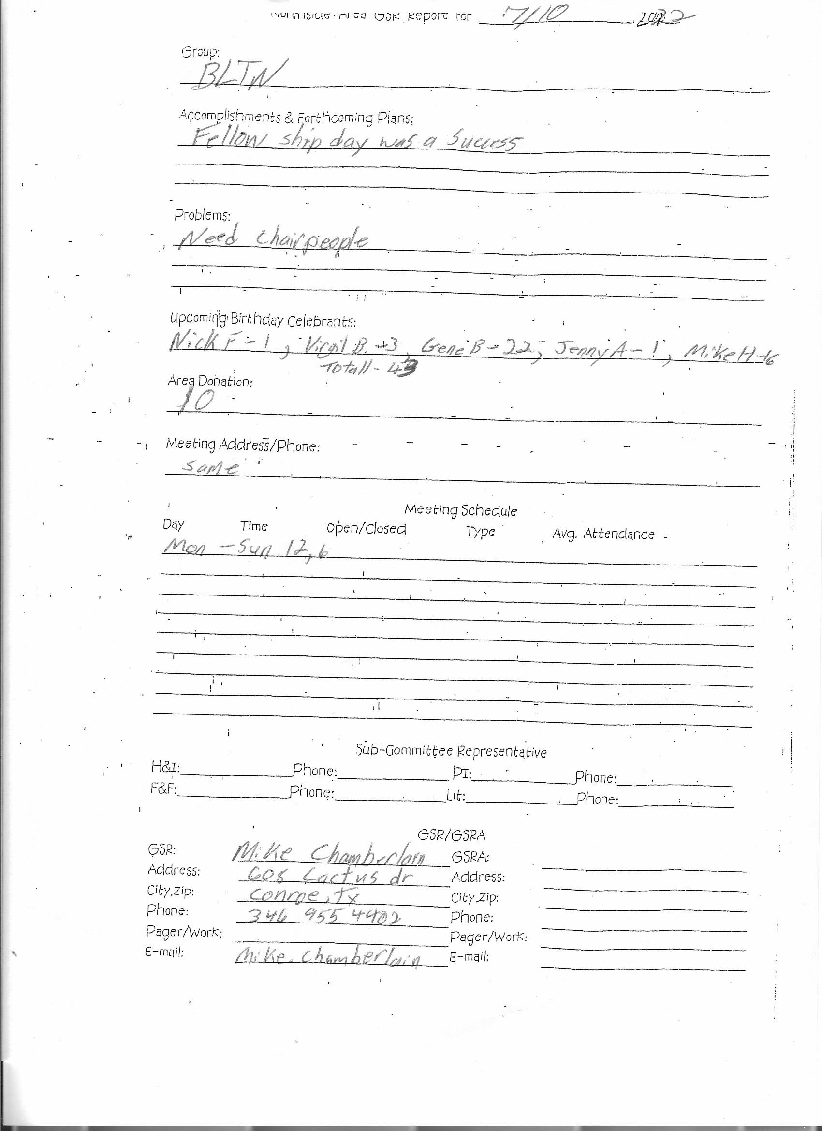

Cypress Group
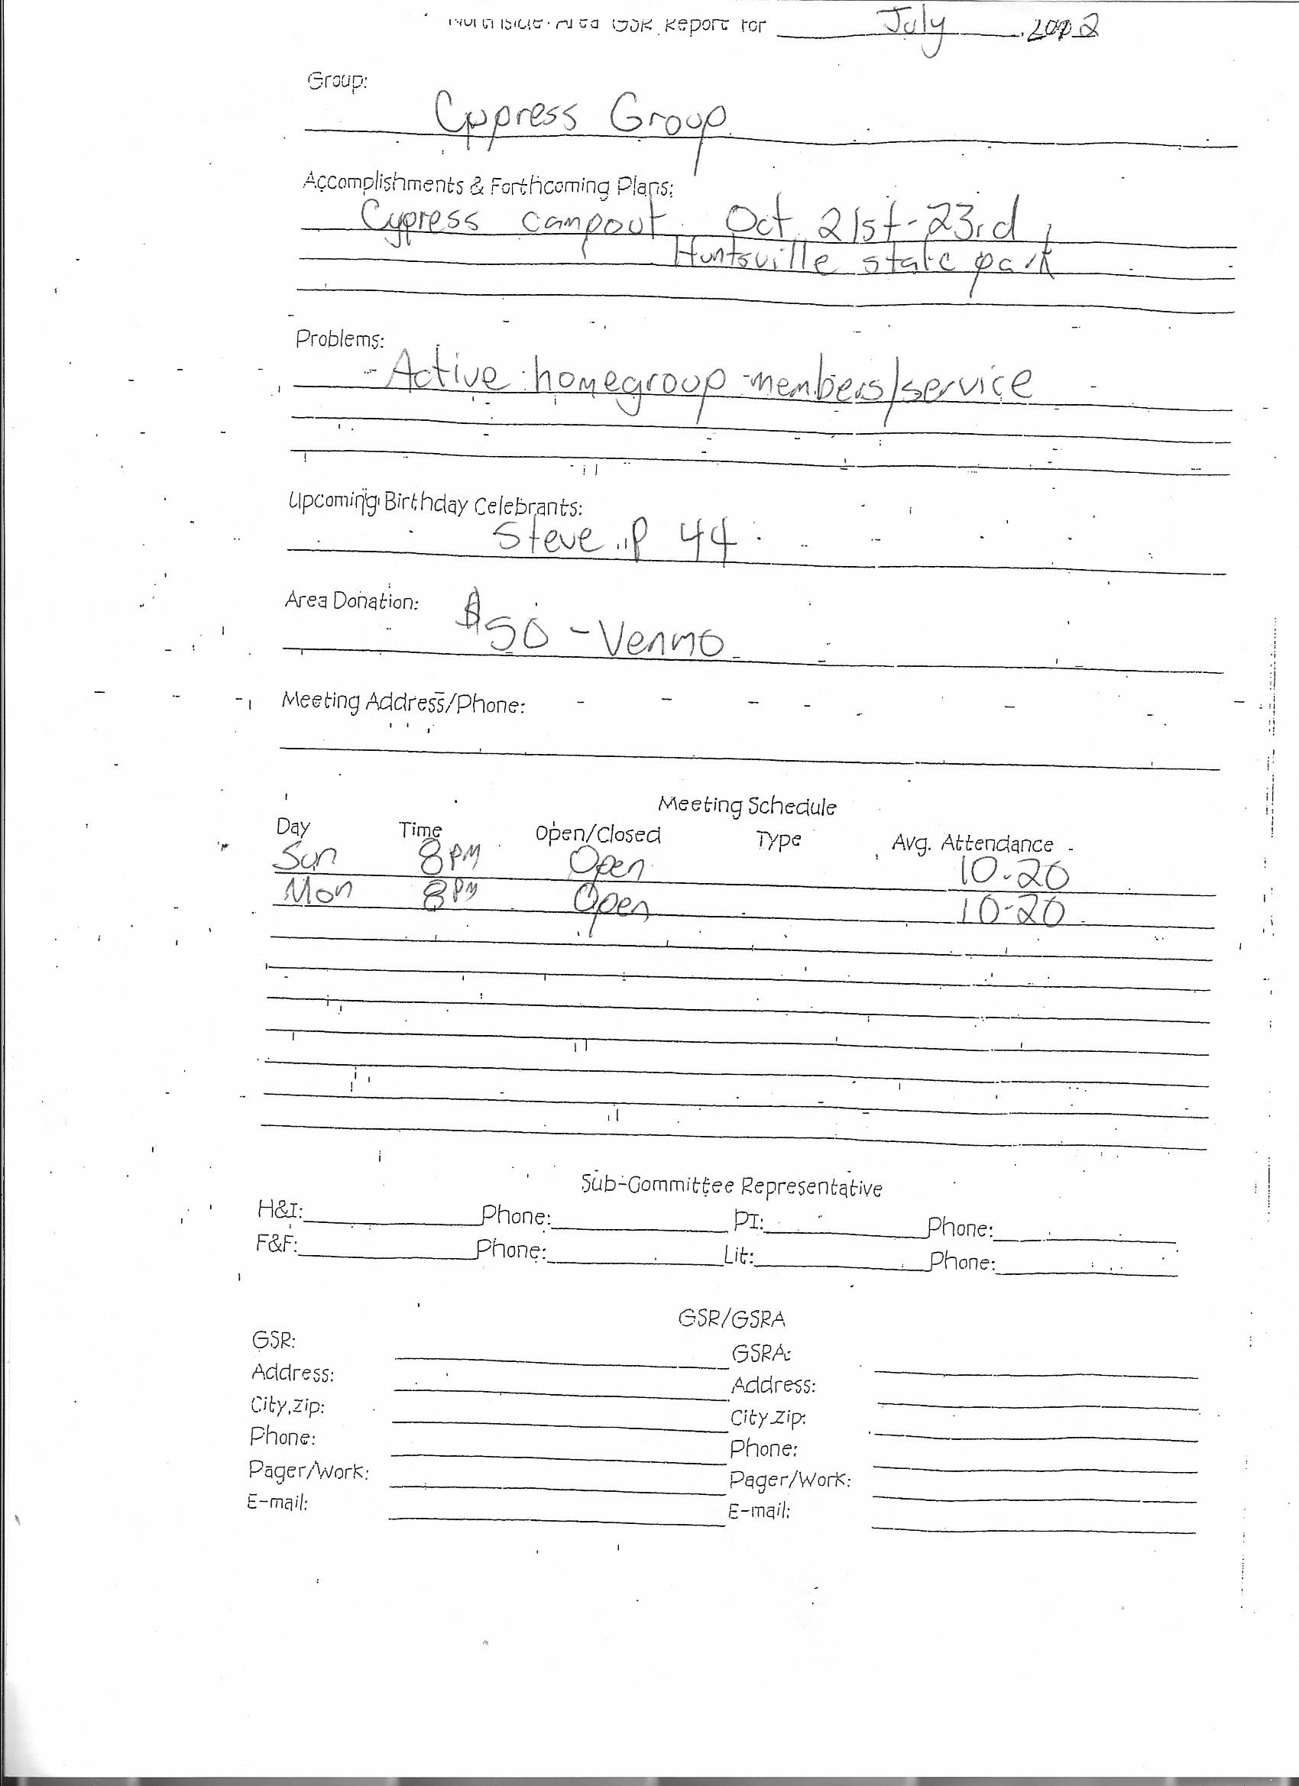

Happy, Joyous and Free
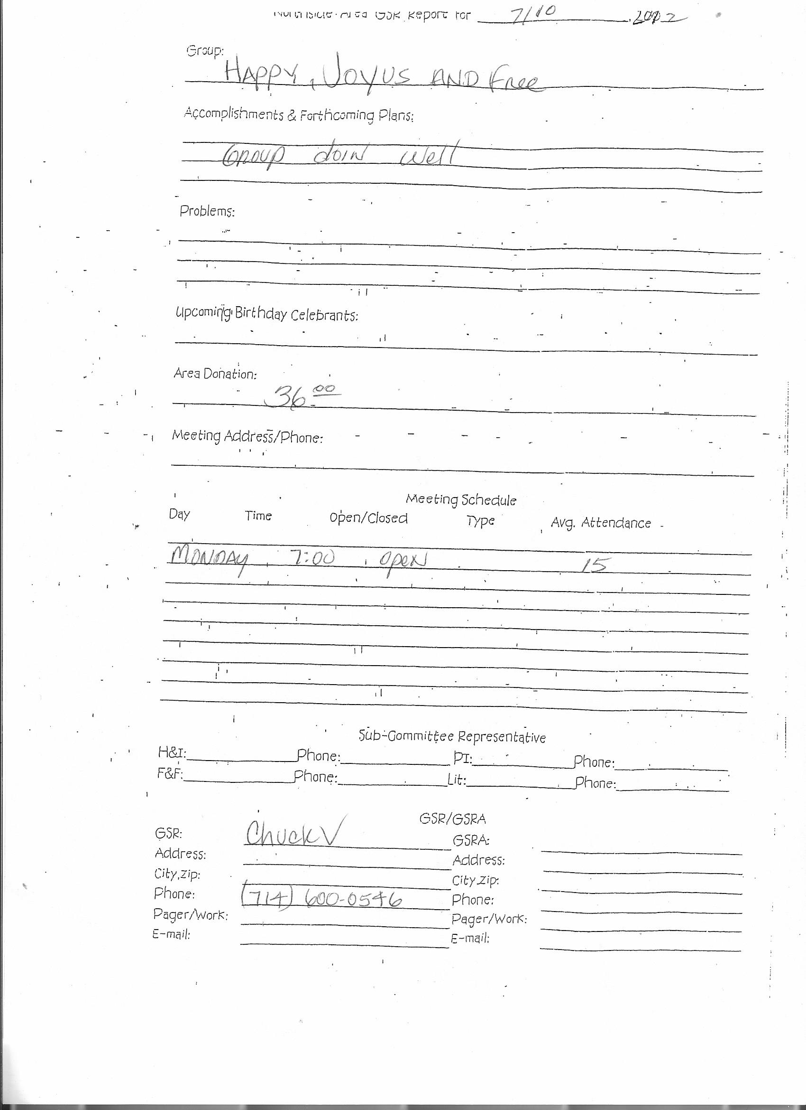

New Hope

RIP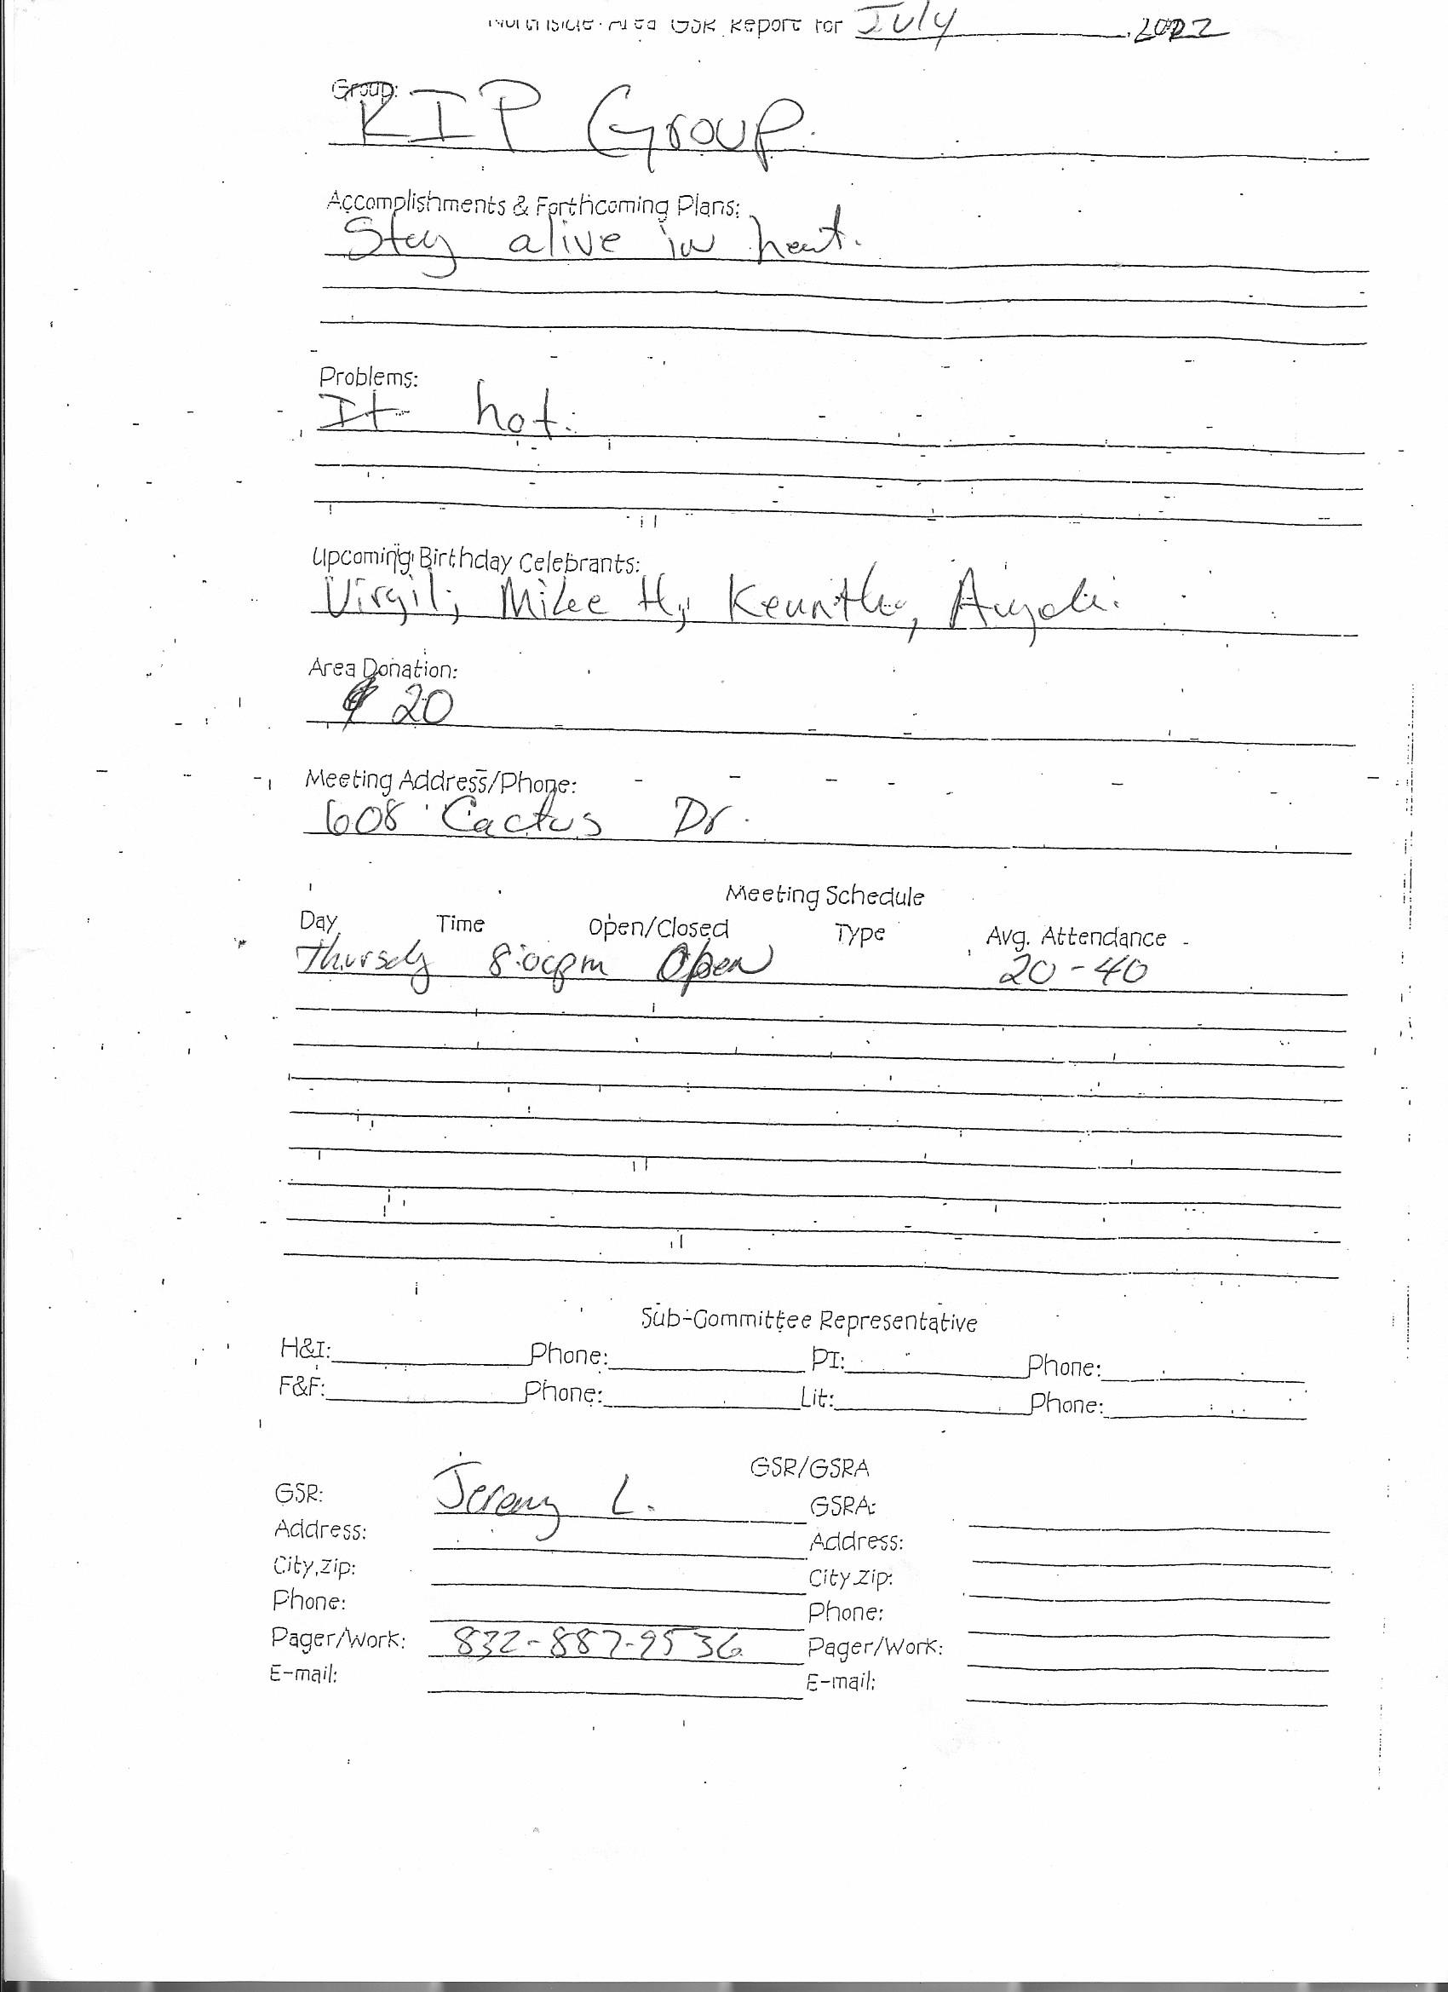

Show Up and Grow Up
Good morning all. I’m Lance T. GSR for the show and grow up group.

We have made a 20.00 dollar donation to area for the month of June

Our attendance average about 15 to 30 people at our meetings.

We Renee R. celebrating 30 years Clean in the month of July.

We are having our 3rd anniversary speaker marathon meeting celebration on July 16th from 4-9pm. We will have 5 speaker sharing their ESH on 5 separate topics. There will be served at around 7 and snacks available throughout the day. The event is located at meeting place in the community room.

We meet on Wednesday at 7:30. Our meeting address is Faith United Methodist Church 2403 Rayford rd. Spring TX 77386.

Thank you allowing me to be of service
Lance T.
--
Thanks, Lance Thompson

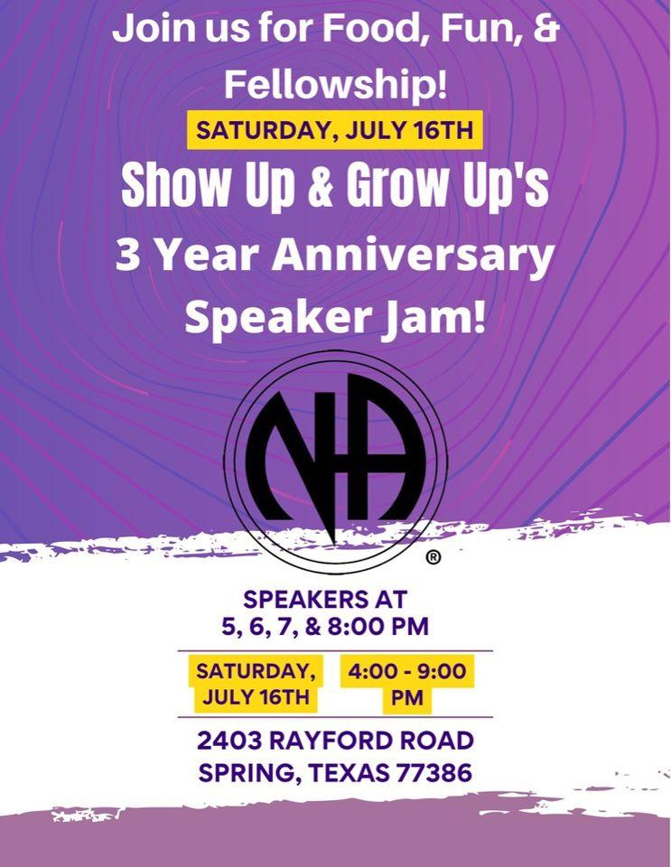

Unfinished Business
Policy proposal regarding the distribution of funds from FBTL
Line B – to be distributed
Propose remaining funds go to H&I, PR, and Activities
Creating caps
Take back to groups
Policy proposal to change remaining FBTL funds to be distributed between local H&I, local PR, and Area Activities.

Sharing
Jennifer: Geographical West Houston has created a Co-Op. Want to help meetings on west side.
Our Common Bond – last Sunday 10:30am 5108 E 5th St. Katy
Provide services to recovery centers on west side.

Going into effect Jan 1. Price increase of about 15% on books No increase for keytags, IPs. Increase for medallions.
SPAD books available @ Nov.
New Business
New Hope 24th Anniversary 9/25 at Lake Houston State Park
Show Up and Grow Up 3rd Anniversary 7/16 4-9pm
Elections
1 open position Lit Review
Next ASC June 5, 2022

Recorded to the best of my ability with help from Samantha

Scott Caggiano
NASCONA Recorder

All bank statements and spreadsheets are available for review at anyone’s request.

