NASCONA ASC May 1, 2022

Jeremy opened meeting with Serenity Prayer
Someone read 12 Traditions
Someone else read 12 Concepts
Jeremy read purpose of ASC
Jeremy read Service Prayer
Vicki called role of Groups
Groups present:
BLTN
Cypress Group
Happy, Joyous and Free
New Hope
RIP
Show Up and Grow Up

Vicki called role of Trusted Servants
Trusted Servants present:
Facilitator - Jeremy
Treasurer – Debbie
Co-Treasurer - Vicki
Recorder – Scott (late)
H&I - Robert
PR - Larry
RCM1 – Shawn
RCM2 - Paul
Activities – Glenna

REPORTS
Jeremy read Recorders report – see APR 2022 ASC Minutes

Treasurer Report – Debbie
Treasurer Report
May 1, 2022

Bank balance: $5,098.43
Prudent Reserve: ($900.00)
FBTL: $3,960

BALANCE: $238.43

Checks not cleared:
1603 Larry Moore ($46.55)
1604 HASCONA ($120.00) – shared services
1605 Terrace United Methodist Church ($85.00) – H&I

Deposits: $599.00 (cash - bank)
$939.85 (Square)
$100.00 (Venmo)

Deposits not credited: $939.85

WORKING BALANCE: $926.73

I figured out where the $20.00 discrepancy came from last month… In the midst of the bank chaos, I had not transferred $20.00 from Venmo from a March donation ☹. So, we are all balanced! There was no missing $20.00 (and I just added this back into our ledger)!
Made quarterly donation of $250.00 each to Region and World.
Sent check for $120 to HASCONA for annual phoneline contribution.
Check from One Source Printing was sent again, and finally cashed 😊

RCM – Sean
Nothing from previous month. Sent a survey about pandemic. 3 questions. Will discuss. Zoom vs. Hybrid
RCM2 – Paul
H&I Service Day and Region coming up. Won’t need funds.

H&I – Robert
Zoom meeting this morning about H&I Learning Day. Need check from Area for $200 for food. Need help for setup and clean up.

Scott gave Robert the rest of the books he had. We need more literature to take into the prisons. Learning Day May 21. At Ties that Bind group.

PR- Larry
Asked which groups need schedules. We need to plan on making an order soon. Post an email to 0123 that groups need to get schedule changes in.

Literature Review
No report this month
Activities – Glenna
Greetings!
I cannot express how wonderful it was to see everyone work together to make this campout the best! Attached is a summary of the income/expense of the weekend.
I would appreciate having a brief activities meeting today
for constructive input about campout. and to discuss our next event
ILS
Glenna K

Womens | x | $ 22.00 | $ -
Mens | x | $ 82.00 | $ -
Saturday speaker | x | $ 79.00 | $ -
Ice | x | $ (14.00) | $ -
ice | x | $ (10.00)
Groceries | x | $ (30.00) | $ -
Square fee |  | $ - | $ (26.15)
 |  | $1,026.00 | $ 939.85 |  | $ 1,965.85
 |  |  |  |  | $ (196.71)
 |  |  |  | net | $ 1,769.14
groceries |  | $ 106.81
donuts |  | $ 89.90
 |  | $ 196.71 | receipts to reimburse

Web Servant

Co-Facilitator – Samantha
No report this month
Ad Hoc

Group Reports
BLTN
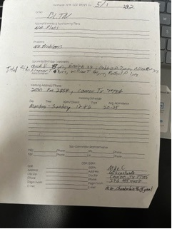
Cypress Group
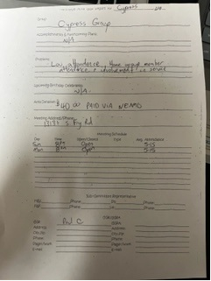

Happy, Joyous and Free
No new information

New Hope
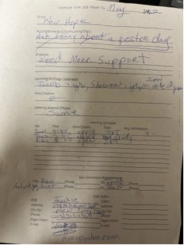
RIP
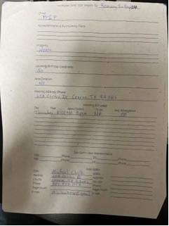
Show Up and Grow Up
Good morning all. I’m Lance T. GSR for the show and grow up group.

We have made a 20.00 dollar donation to area for the month of April.

Our attendance average about 15 to 30 people at our meetings.

We meet on Wednesday at 7:30. Our meeting address is Faith United Methodist Church 2403 Rayford rd. Spring TX 77386.

Thank you allowing me to be of service
Lance T.
--
Thanks, Lance Thompson

Unfinished Business
none
Sharing
Discussed 501(c)(3) status for NASCONA. Vicki says it is not a big hassle. We need to discuss benefits vs. costs. One of the reasons we asked about it was because of banking regulations. Vicki says we can file for $200 rather than the $600. It will make transfer of signers on the bank account much easier. Get one person’s SSN off the account. Annual filing can be completed on a postcard. Larry shared that all the information would need to be put into policy. Larry asked Vicki if she would summarize the duties. Debbie will write a proposal for new business.
Discussed if we need to put the HASCONA phone line donation into policy.
Jackie asked Larry if PR would help New Hope put on a poster day.
Robert shared that H&I needs books. Trying to decide how much to request.
Vicki shared that WOODNA has brought up the idea of getting meetings started in hospitals. Vicki will contact Lauren to see which facility she was attempting to get into.
Sean had questions for the groups on some information he wanted to take back to Region.
Which groups have returned to pre-pandemic attendance?
Show Up and Grow Up – increased attendance
Cypress Group – Increased attendance
New Hope – decreased attendance
RIP – back to pre-pandemic attendance
BLTN – back to pre-pandemic attendance
Which groups have grown larger?
Same question
What did you see any of these groups doing to increase attendance?
Show Up and Grow Up – Cross meeting traffic
HJF – Hybrid meetings can bring people from online to in-person
RSC is hybrid. Trying to get back in person. Asking for the groups’ conscience on whether they think RSC should be Zoom, Hybrid, or in person.
Jeremy said Zoom could cut costs. Debbie brought up the $75 per diem. Zoom is a good option. Larry said that with Zoom meetings, the subcommittees that break out wouldn’t have to miss the RSC.
It was suggested that NASCONA make the proposal on changing the RSC format.
Robert shared that Zoom can be a gift to NA that can be shared many ways.
Asked Sean to write a proposal that we can bring back to groups.
New Business
Debbie proposed that NASCONA’s annual donation to HASCONA for shared services be written into policy and include referring to the prior year’s dollar amount. Sent to groups.
Debbie proposed that NASCONA move forward with filing for 501(c)(3) status. Sent to groups
Robert proposed that NASCONA spend $405.64 for H&I literature. Accepted
Sean proposed that NASCONA make a proposal to TBRNA that RSC meetings be Hybrid or Zoom. Exact wording of proposal to follow. Sent to groups.
Elections
1 open position Lit Review
Next ASC June 5, 2022

Recorded to the best of my ability.

Scott Caggiano
NASCONA Recorder

All bank statements and spreadsheets are available for review at anyone’s request.

