NASCONA
September 12, 2021
Larry opened meeting with Serenity Prayer
Ron read 12 Traditions
Sean read 12 Concepts
Larry read purpose of ASC
Billy read Service Prayer
Scott called role of Groups
Groups present:
BLTN
New Hope
RIP
HJ&F
WoodNA
Scott called role of Trusted Servants
Trusted Servants present:
Facilitator – Larry
Treasurer – Jeremy
Recorder - Scott
RCM1 – Shawn
H&I – Robert
Activities – Glenna
Web Servant – Steve

REPORT
Scott read Recorders report – see August 2021 ASC Minutes
Jeremy gave treasurers report

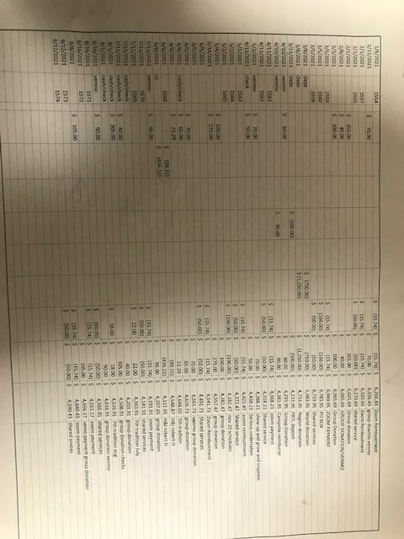
$13 cash collected in 7th Tradition Basket

Shawn read RCM report
Robert gave H&I Report
Currently still doing mtgs at 2 locations.
Holliday unit Tues 330 to 430
O.l. Luther trustee camp
Wed 5 to 6
3 volunteers
Will need to make another literature order.
H& I will meet right after area today.
Thank you
Robert H

Todd gave PR Report
(Note from recorder: I apologize for the incomplete notes on the PR Report. I thought there was a report emailed, so I had just a few notes from Todd’s verbal report.)
PR is looking into supporting Memorial Herman
Still working with Mallard Lake

Activities Report
Glenna
Possibly Stickers for FBTL
Glenna has talked with TPW for booking for 2022
Web Servant
Steve
In process of cleaning things up.
Flyers for upcoming fundraisers.
Scot has access to website for policy changes.

Break

Group reports
BLTN
9:30 Saturday meeting getting a lot of newcomers
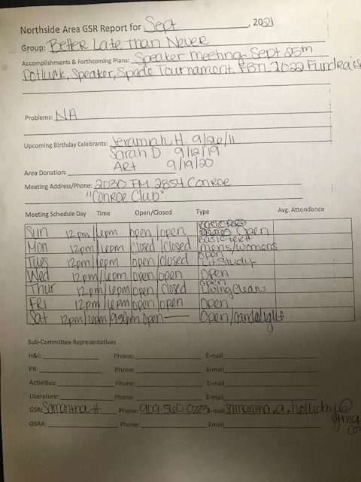

HJF
In person meetings and zoom
Methodist Church Lake Woodlands
Monday 7pm

New Hope
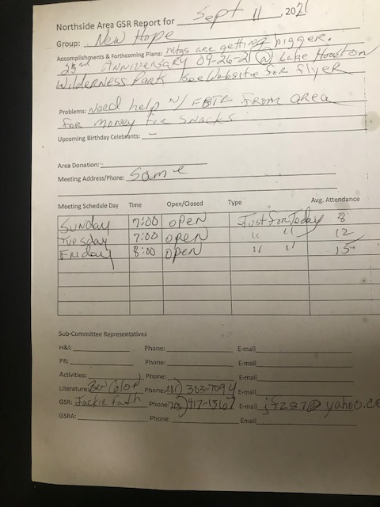

RIP Group
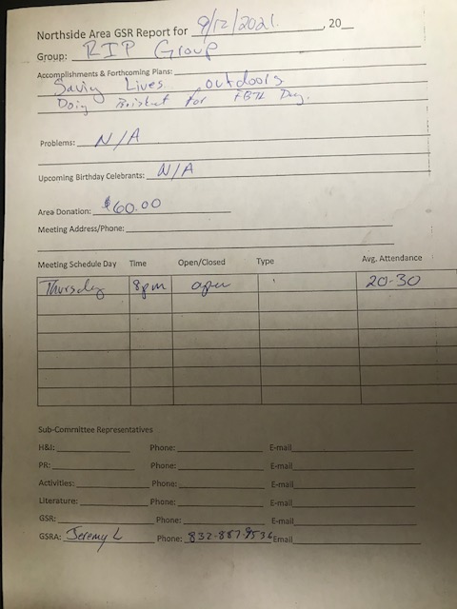

Woodlands Group
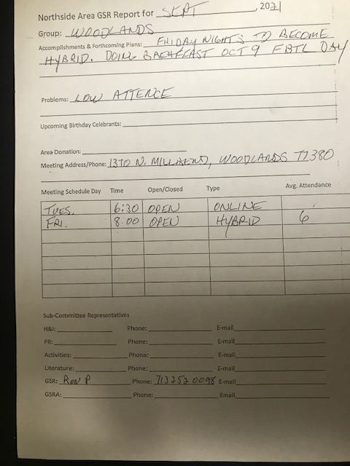
Sharing
Trying to figure out fundraising for both 2021 and 2022 FBTL. BLTN has earmarked their fundraiser money for 2022. FBTL may not have enough money to reserve campsites for 2022.
Area can front the money to FBTL.
Robert asked for 554.47 for H&I. Previous money spent on H&I was from 2019 FBTL.
Larry discussed changing meeting format
Ron asked ASC for input to help increase attendance. Several suggestions about FOOD. Suggested that WoodNA members attend other meetings. Bring something to another meeting. Todd discussed an Outreach subcommittee. Put Zoom meeting info out to GSRs. Samantha suggested that GSRs announce that a Group needs support.
Jeremy will not be attending OCT. ASC. If anyone needs checks, get them before then.
Jeremy discussed payment to Conroe Club for rent for ASC meetings. We sent Jeremy to Conroe Club meeting to ask what they want for back rent.
No old business
New Business
Jackie proposes that Area provide up to $75 for snacks for FBTL. Approved.
Robert proposes that Area provide 554.47 for H&I Literature. Approved.
Glenna proposes that Area provide whatever funds are needed to reserve campsites for FBTL 2022. Glenna is in favor of hybrid meetings. Brenda agrees with Glenna. We’re not sending it back to Groups at this time.
Jeremy proposes that Billie Stone be removed as a signor from Woodforest Bank account Number XXXXXXX1661. Approved. Scott will write the letter.

Next ASC October 3
Close

