NASCONA
October 3, 2021
Larry opened meeting with Serenity Prayer
Sean read 12 Traditions
Glenna read 12 Concepts
Larry read purpose of ASC
Steve read Service Prayer
Scott called role of Groups
Groups present:
BLTN
Cypress Group
New Hope
RIP
Show Up and Grow Up
WoodNA
Scott called role of Trusted Servants
Trusted Servants present:
Facilitator – Larry
Recorder - Scott
RCM1 – Shawn
H&I – Robert
Activities – Glenna
Web Servant – Steve

REPORTS
Scott read Recorders report – see August 2021 ASC Minutes
Larry read Jeremy’s emailed treasurers report
https://1drv.ms/x/s!BHZm7NiQNbkEjHJSGTzlqgXEUpOm?e=JSXGUIfsQ0eUfId8jpVG9g&at=9
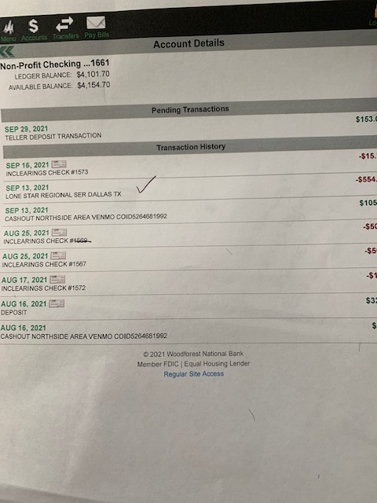

$21 cash collected in 7th Tradition Basket

Shawn read RCM report
RCM 1 Report 10-2-2021
Currently in between scheduled conference dates. Below is good information to share with the groups.
TBRCNA 2023 is looking for committed volunteers to join and serve on committee for the convention in Beaumont.
The approved draft of the Spiritual Principle a Day will be available for download 11/24/21 na.org/conference
Tape bound copy available for $10 + s&h. Na.org/webstore
A guide to virtual meetings best practices can be found at na.org/toolbox
Sean H.

Robert gave H&I Report
Hello family.
We have 2 meetings we are covering in tdcj
Tues 330 430 Holliday unit
Wednesday
5 to 6 pm
Also donated literature for men at Huntsville unit.
Attached is receipt for literature purchase.
Thank you
Robert Hoop

Paul gave PR Report for Todd
PR is looking into QR cards vs. printed schedules
Scott added that the schedules had been delivered to Jeremy and would be distributed next week.

Activities Report
Greetings!

Super excited FBTL will be this Saturday!
The stickers were printed and will be at meeting
Sell for $3 each or 2 for $5

Need to borrow coolers for drinks , Airpot for coffee if anyone has these let me know please.

Attended New Hope's anniversary
Good turn out, good food. good fellowship.

Better Late than Never has Tshirts for sale. Proceeds benefit FBTL 2022

Next Activities meeting will be Monday October 18th 7:15 at BLTN

ILS
Glenna K

Web Servant Report
Steve
Planning on getting reports on to the website.
Has received emails and will address them

Break

Group reports
BLTN
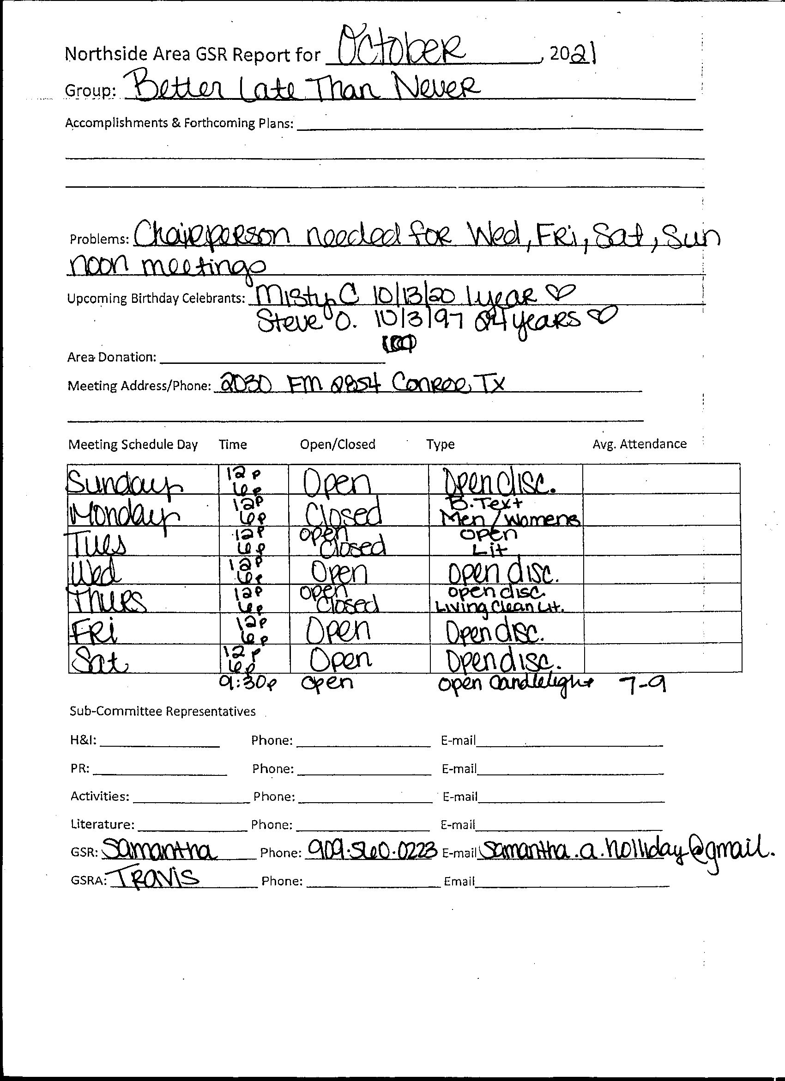
Cypress Group
Hello Family,

My name is Paul and I am an addict. Cypress group of NA is currently meeting in person at our regular meeting times and place as follows:

Sunday 8-9 pm
Monday 8-9 pm

13131 N. Fry Rd, Cypress, Tx. 77433

We do not have any zoom meetings at this time. Attendance has been high lately with approximately 15-20 people at each meeting. We have 1 birthday celebrant so far (Brian N.-18 yrs.on 10/11) this month. Brian N. Made an electronic payment via the area Venmo for area donation of $68.00 this month. Thank you all for your service.

Paul C.

New Hope

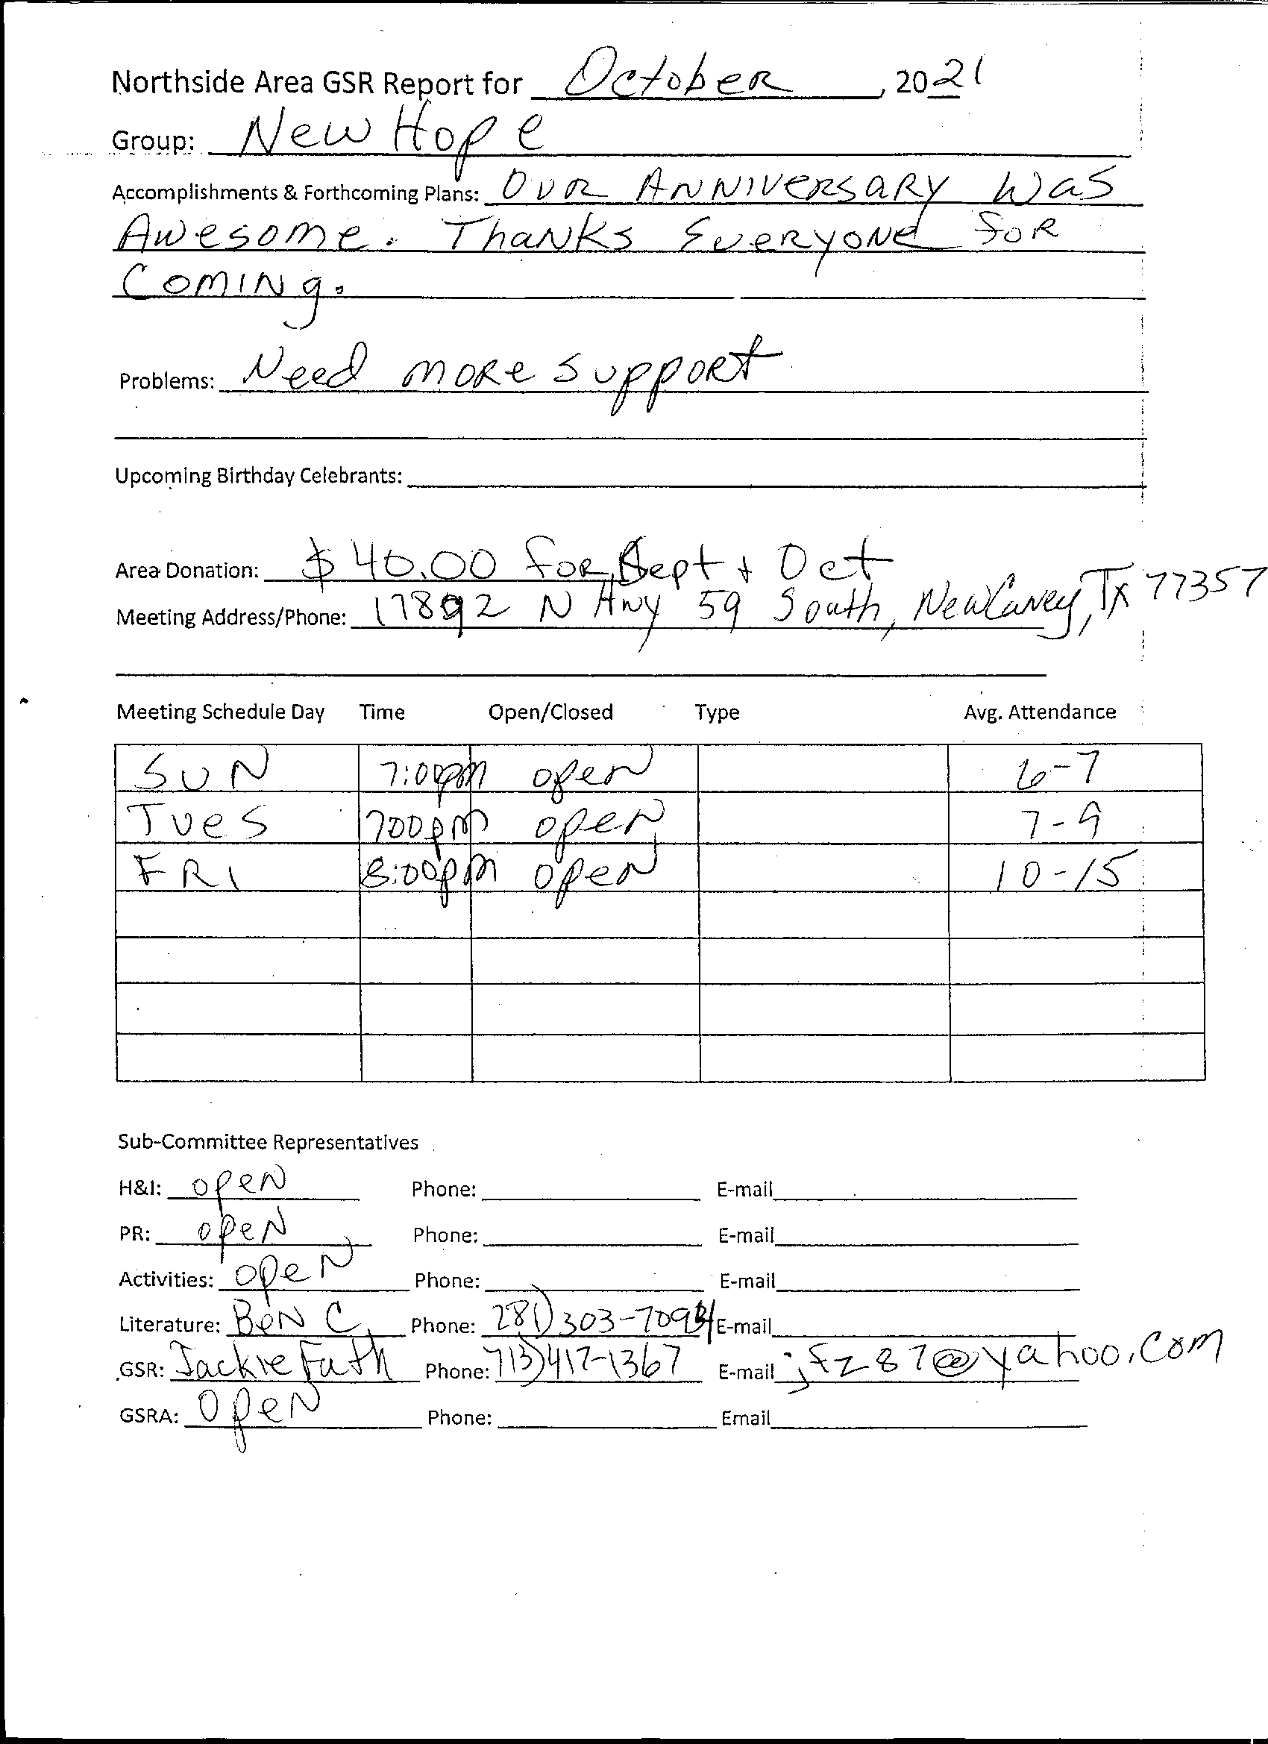
RIP Group

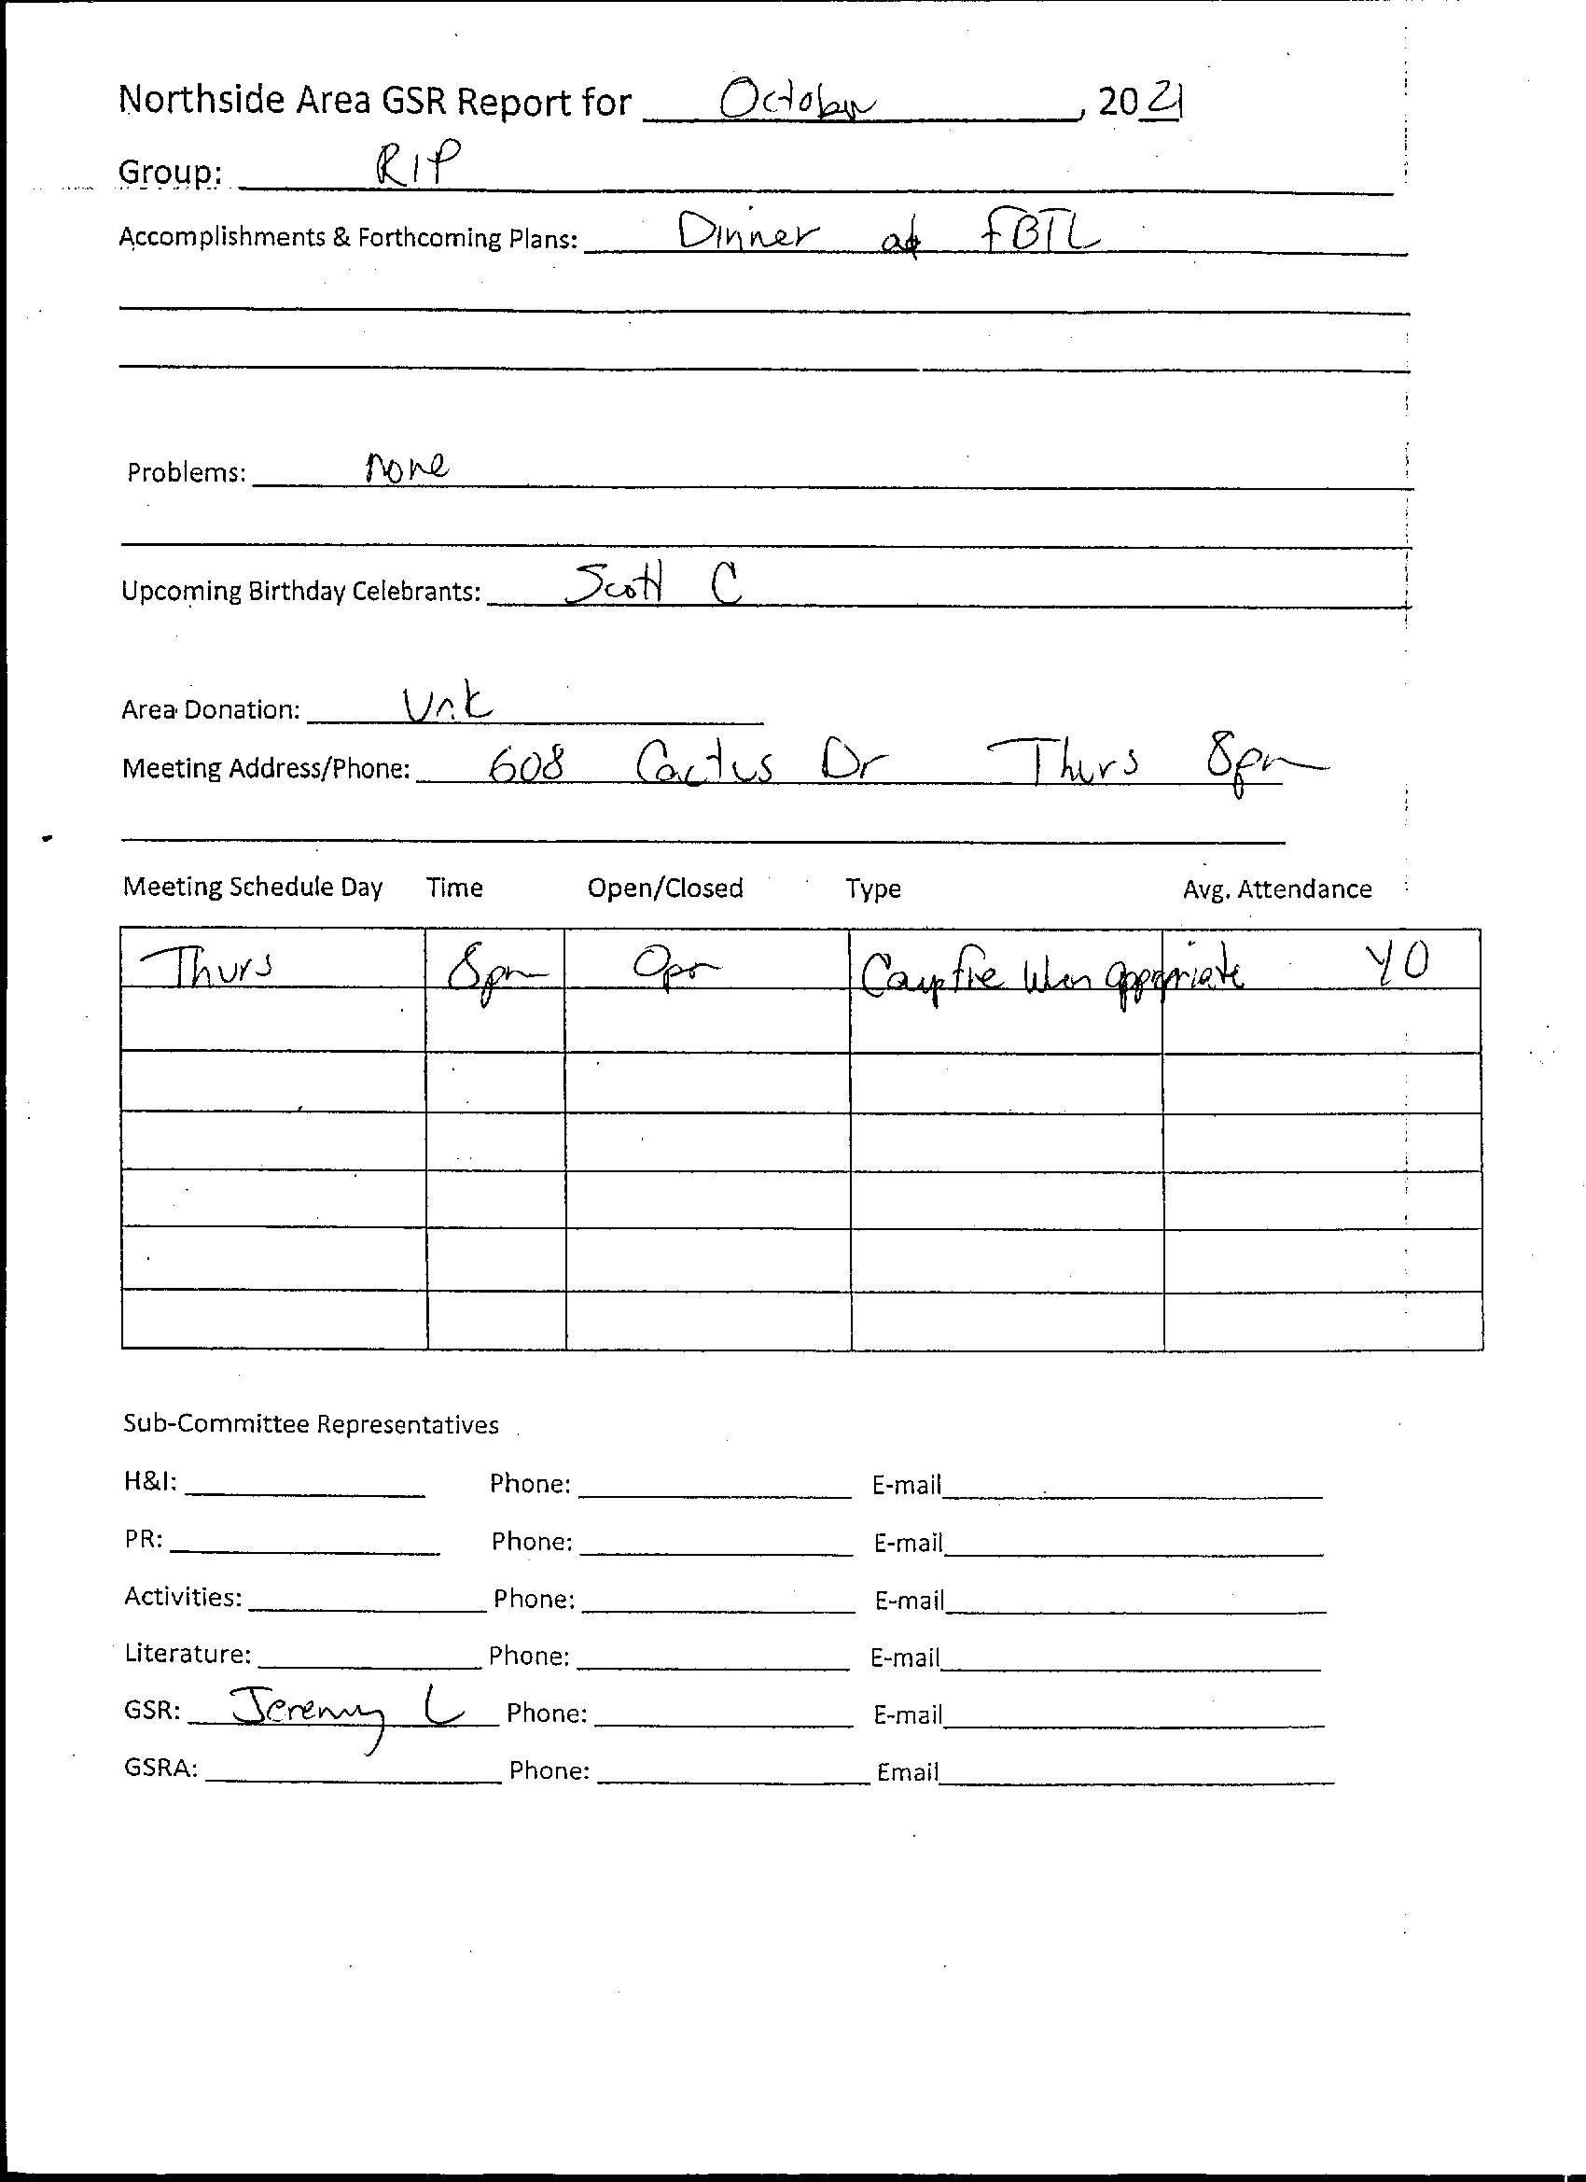
Show Up and Grow Up
Good morning all. I’m Lance T. GSR for the show and grow up group.

We have made a 20.00 dollar donation to area for the month of September.

Our attendance continues to grow and average about 12 to 15 people at our meetings.

We meet on Wednesday at 7:30. Our meeting address is Faith United Methodist Church 2403 Rayford rd. Spring TX 77386. We require mask and practice social distancing. Mask are provided if needed.

We have committed to the 3 - 5 slot to serve snacks at the FBTL. Function.

Thank you allowing me to be of service
Lance T.
--
Thanks, Lance Thompson

Woodlands Group
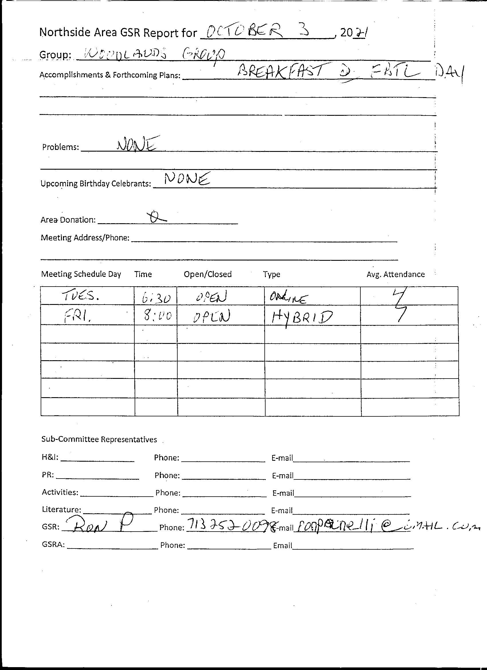
Sharing
Glenna shared activities is looking for groups to host fundraising events for FBTL 2022. Check with your groups to see if your facilities can host. Lots of suggestions. Looking to get ahead so we can plan the events and space them out and get them on the website. Will be paying for campsites in November. Planning a glamping site. Funds will be for 2022 FBTL.
Larry asked about H&I and PR meetings before ASC. Looking to get time and date for those subcommittee meetings so that they can be put out.
Jackie suggested that Northside Area have our own schedules. Support for that idea. We will have to design our own schedule. Will add QR code for Houston Are meetings. Paul will contact Todd and get him to run this effort.
Larry shared ideas about changing ASC meeting format. He would like to switch unfinished business with sharing. This is a policy change will have to go back to groups. Robert suggested that it could be done without going back to groups. Everyone agreed.
Lance suggested we do away with the break. Not very popular. Larry suggested we have break after group reports.
Scott suggested we clarify recorder’s reading of roll call.
Unfinished Business
none
New Business
Proposal to make changes to ASC format. Approved
H&I and PR meetings will be held noon on ASC days. Please get word to groups.

Elections
Sean nominated Paul for RCM2. Qualified himself. Approved!!
Jackie nominated Vicki for Co-treasurer. She reluctantly accepted. She qualified. Approved!!
Vicki nominated Ashley for Literature Review Facilitator. Qualified. Approved!!!
Next ASC November 7
Close

