NASCONA
November 7, 2021
Larry opened meeting with Serenity Prayer
Jeremy read 12 Traditions
Paul read 12 Concepts
Larry read purpose of ASC
Jeremy read Service Prayer
Scott called role of Groups
Groups present:
BLTN
Cypress Group
New Hope
RIP
Show Up and Grow Up
WoodNA
Scott called role of Trusted Servants
Trusted Servants present:
Facilitator – Larry
Recorder - Scott
RCM1 – Shawn
H&I – Robert
Activities – Glenna
Web Servant – Steve

REPORTS
Scott read Recorders report – see October 2021 ASC Minutes
Larry read Jeremy’s emailed treasurers report
https://onedrive.live.com/view.aspx?resid=4B93590D8EC6676!1702&ithint=file%2cxlsx&authkey=!AviOhgT3NIFxDcI

Shawn has nothing new for RCM report
Paul forwarded RD report to 0123

Robert gave H&I Report
Holliday Unit Tuesdays
OL Luther Unit Tuesdays
Hoping to get Women’s Units in Dayton opened up soon.
Angela L. Is talking to warden at Plains State and will continue to try and get approval to bring a meeting in.

PR Report. Todd emailed.
Hello family, I am unable to attend todays ASC meeting as I am out of town on a camping trip with my wife. There is not a lot to report on PR wise. I have feelers out with a couple of local rehabs to see if when can establish a meeting with them or at least an H&I panel.
Thank you for letting me be of service,
Todd B.

Activities Report. Glenna emailed
Greetings I am unable to attend today.
The Fellowship by the Lake event was well attended, our speakers carried strong messages of recovery ; food fun and Fellowship was enjoyed by all

Had an Activities meeting Oct 25th, discussed
Glampout raffle, tickets, things that we need etc
Looking into price of printing

The campsites for Fellowship by the lake 2022 have been secured for April 22-24.
Next Activities meeting Monday November 22
Better Late Than Never following meeting

Ils
Glenna K

Group reports
BLTN
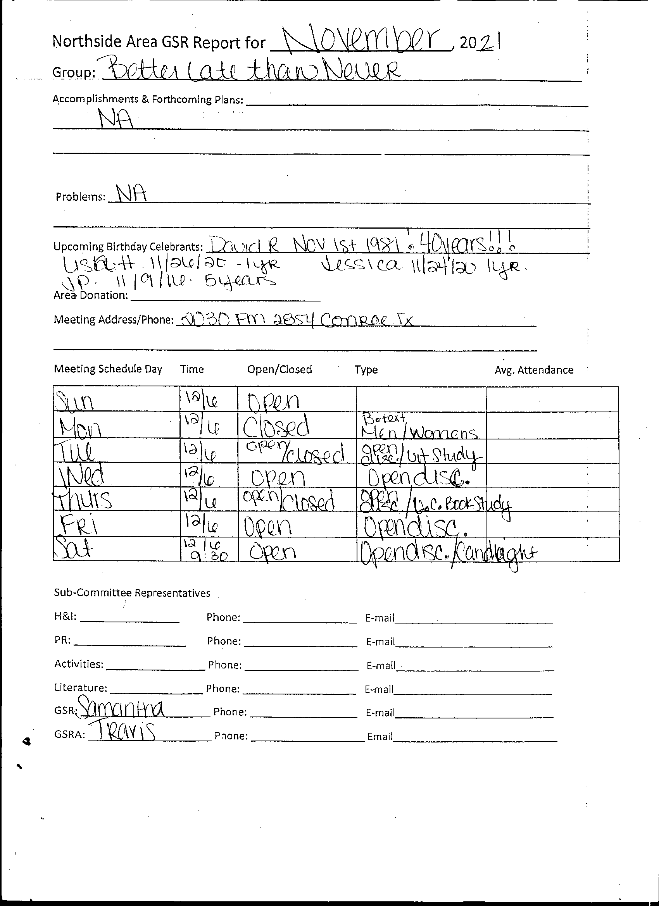
Cypress Group
Howdy All,

I am sorry, but I won't be able to attend today.

Cypress group of NA is currently meeting in person at our regular meeting times and place as follows:

Sunday 8-9 pm
Monday 8-9 pm

13131 N. Fry Rd, Cypress, Tx. 77433

We do not have any zoom meetings at this time. Attendance has been high lately with approximately 15-20 people at each meeting. We don't have any birthday celebrants scheduled so far this month. Brian N. Made an electronic payment via the area Venmo for area donation of $40.00 this month.

Thank you all for your service,
Ashley W.

Happy Joyous and Free
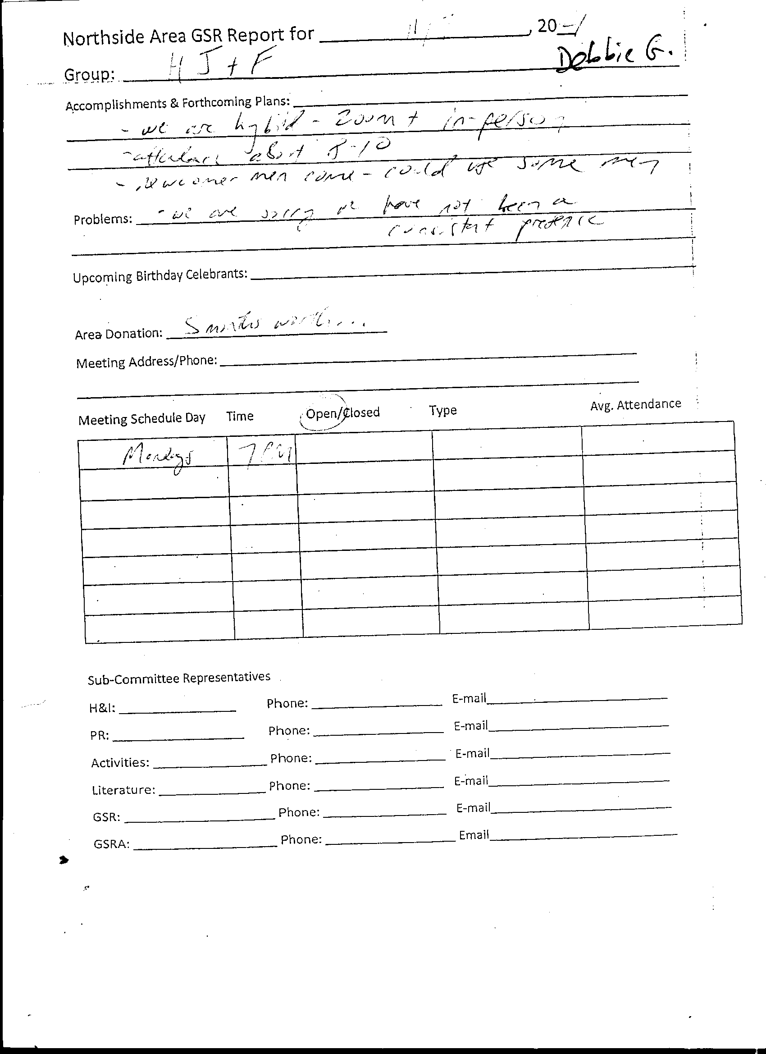
New Hope
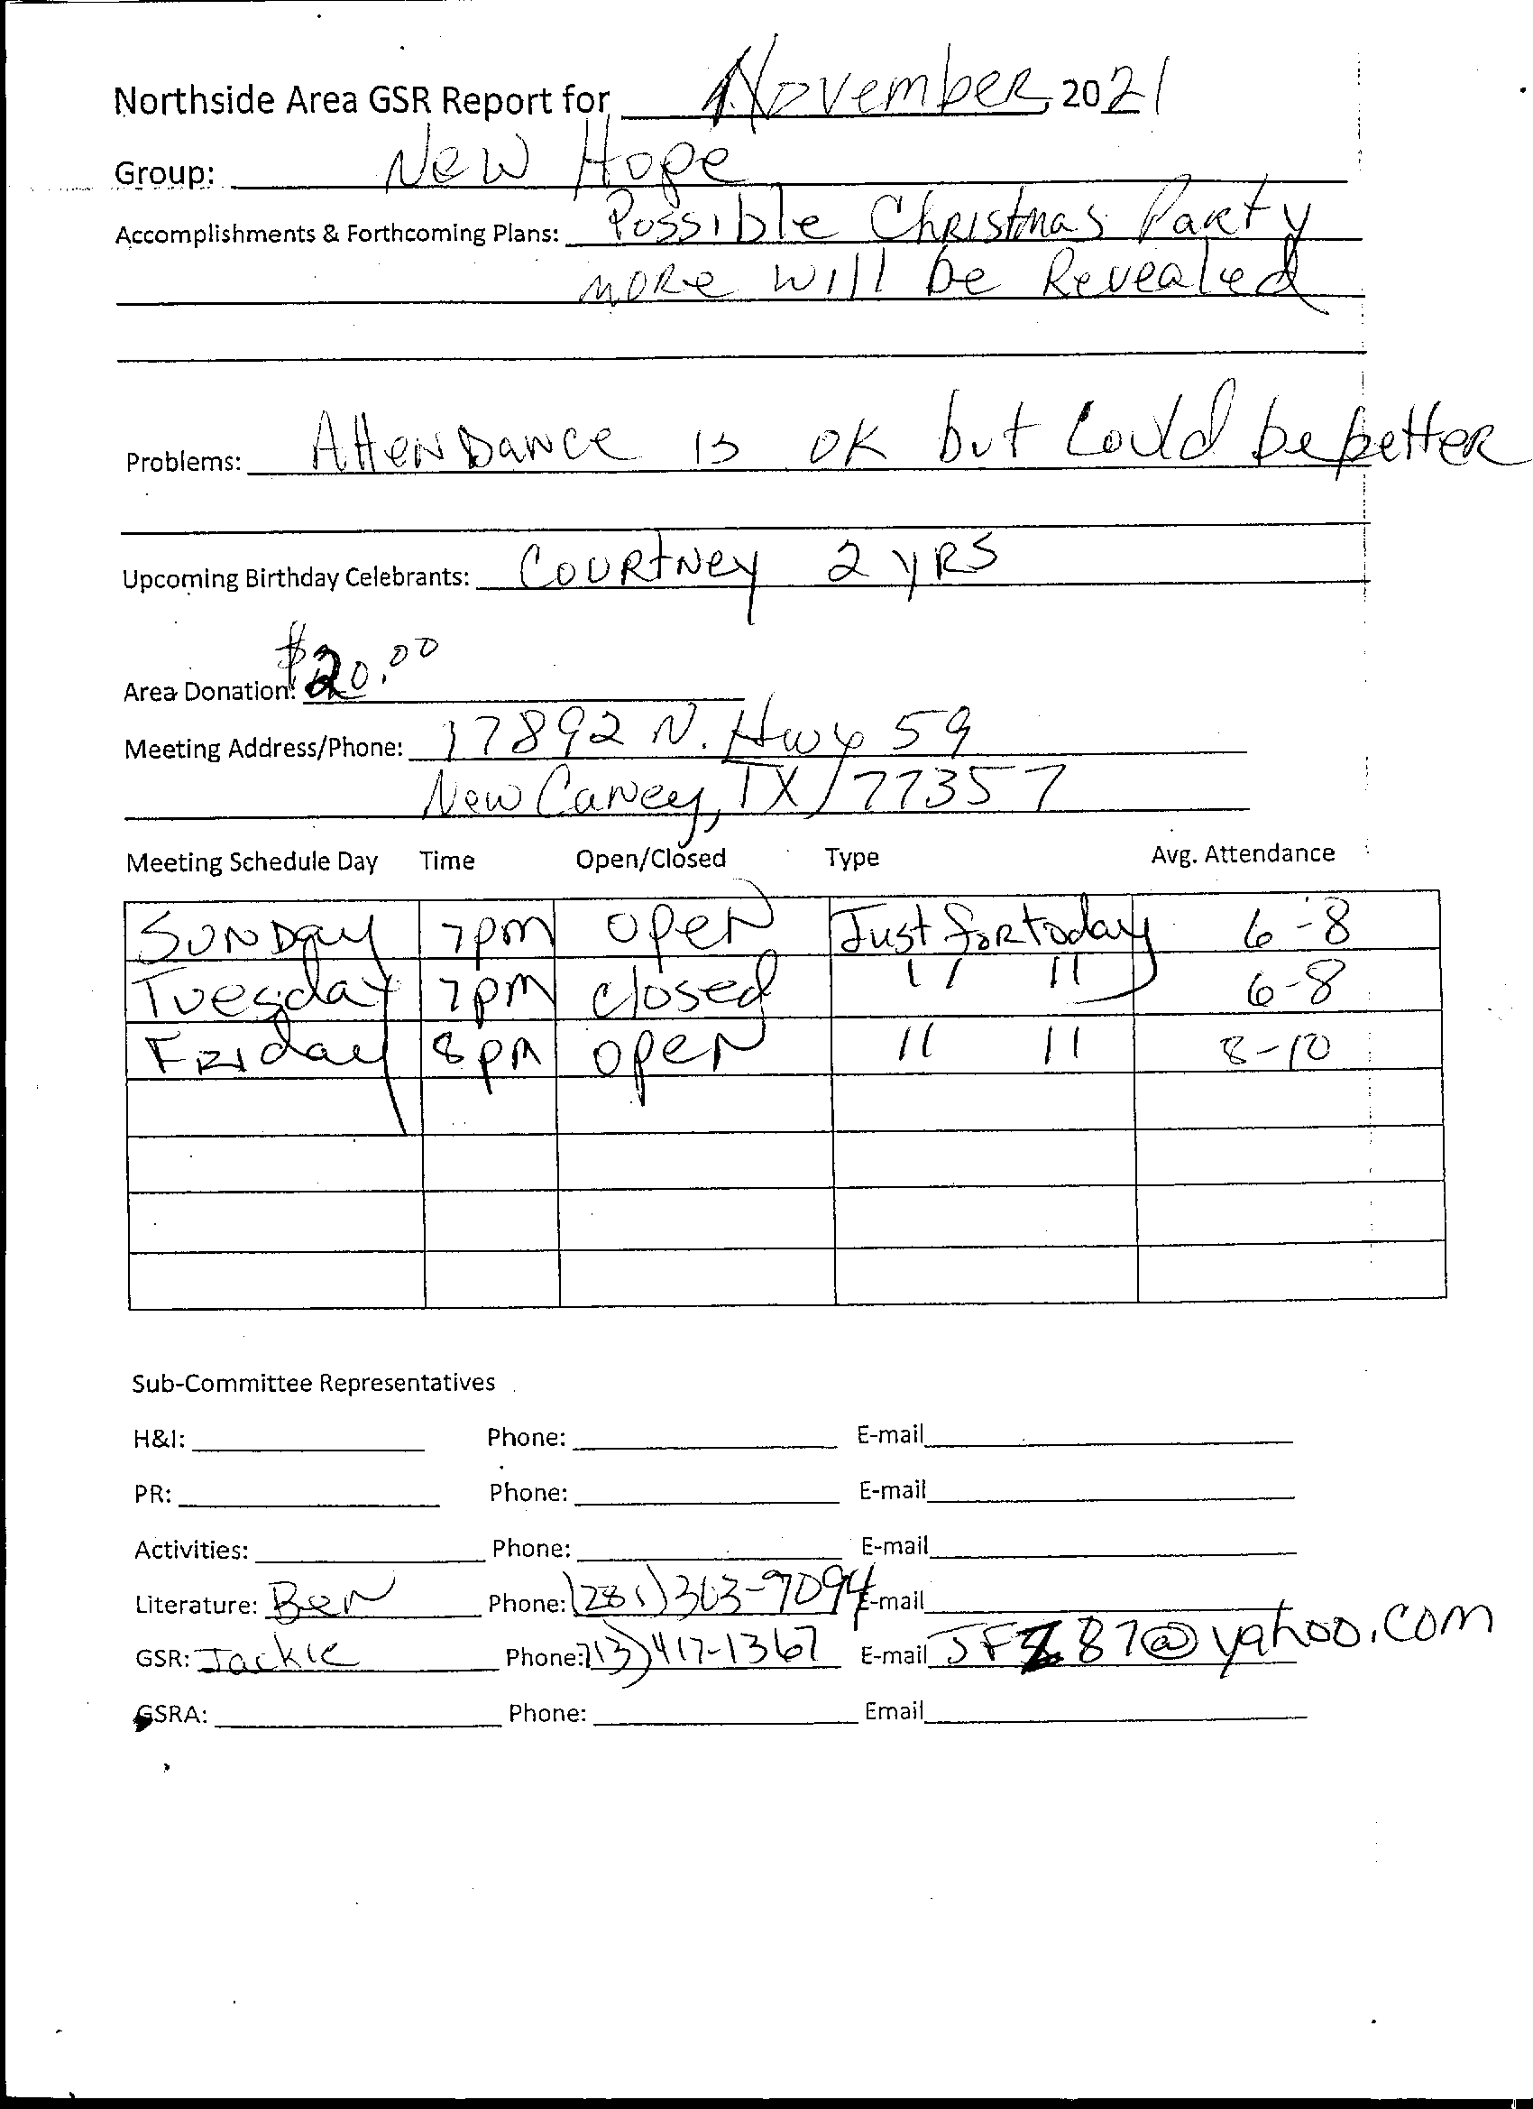

RIP Group
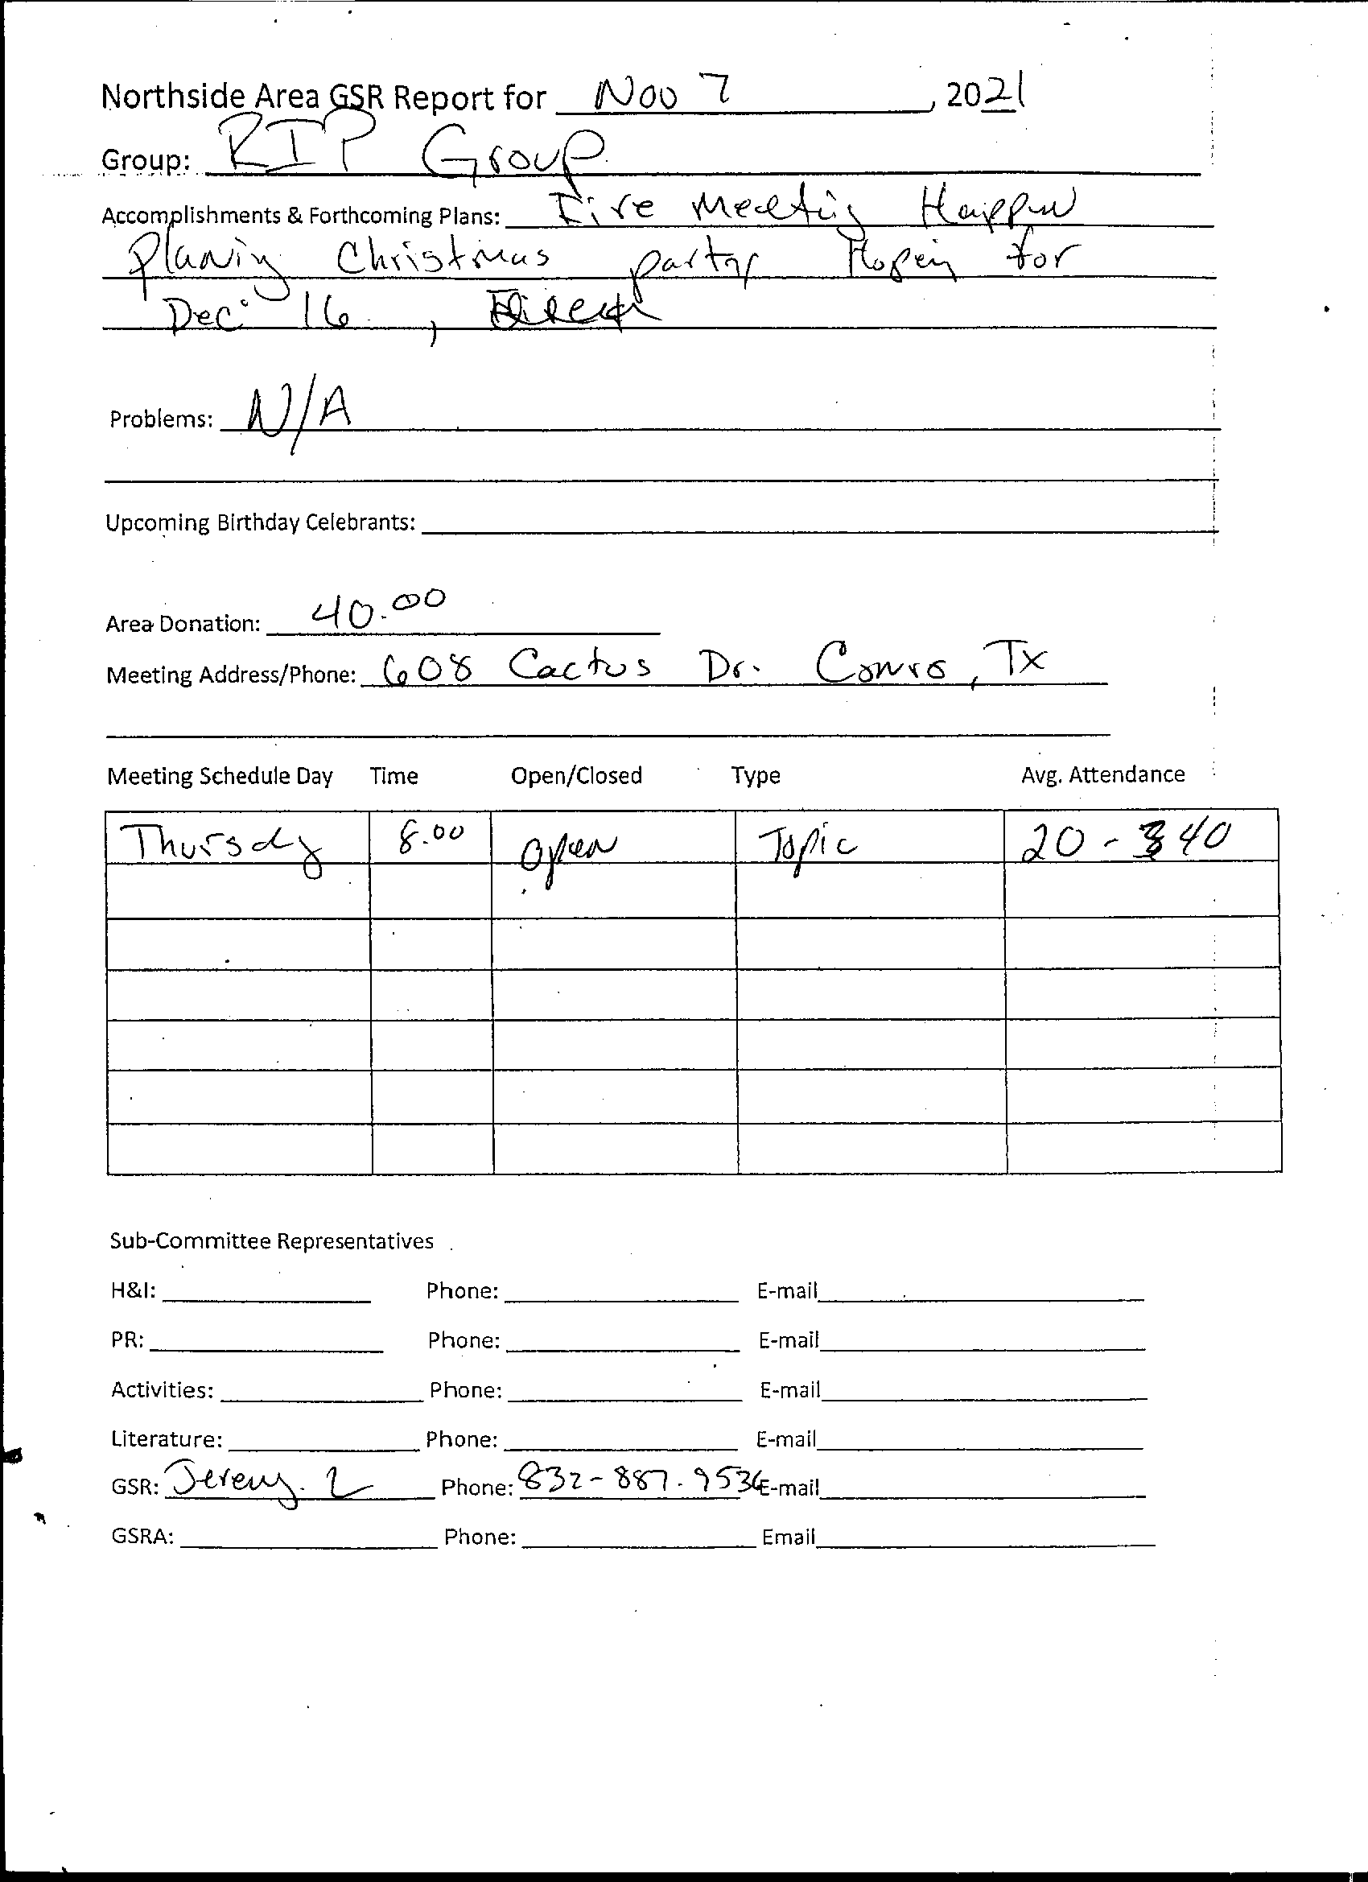
Serenity Happens
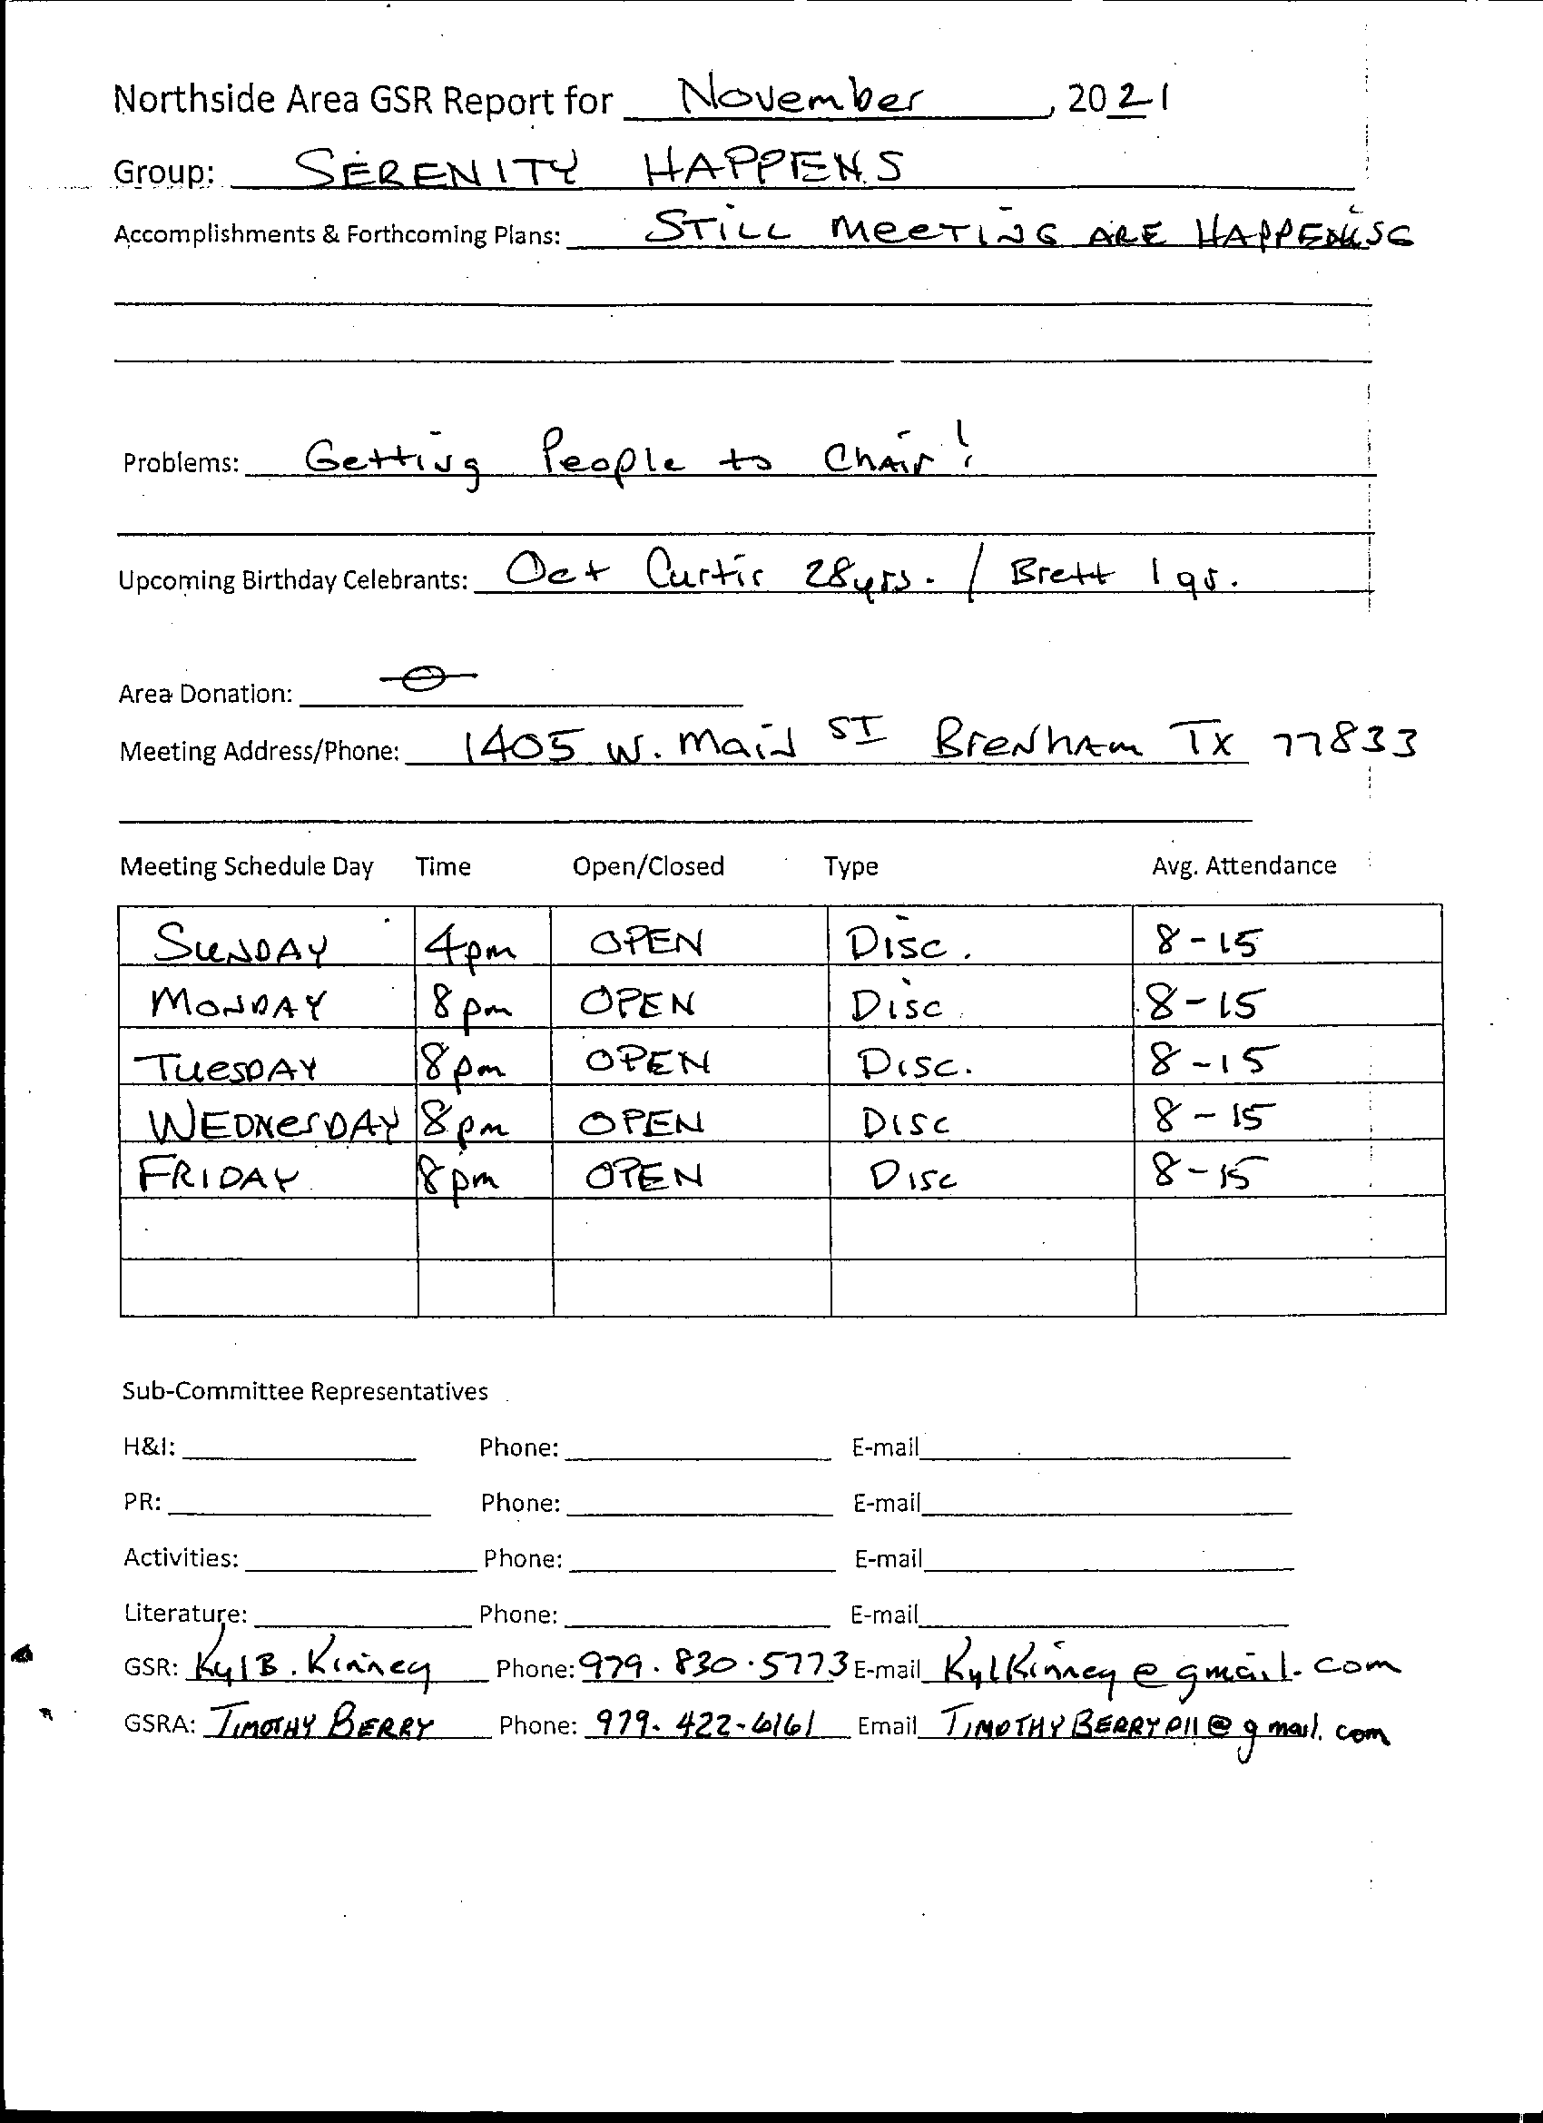

Unfinished Business
none
Sharing
Jeremy asked that we clarify how we are going to make the disbursements from FBTL 2020.
Let Area zero out the negative balance from FBTL 2020 and 2021.
Made Region and World donations in 2021.
Larry proposed that we do an audit.
Jeremy proposed that we give all receipts to Jim from BLTN and get an audit done.
Vicki said that 12 Step Groups could be considered faith based. TDC considers 12 Step substance abuse
New Business
Jackie made motion that Area cover the -$90.67 from 2020 and 2021. Typical disbursements from FBTL will not be made. This will allow Activities to start with a 0 balance for FBTL 2022. Approved.
Robert asked for H&I literature money. $250.00. Approved
Jeremy made motion to have Jim do audit. Approved

Elections
Nominations
Larry nominated himself for PR facilitator. Qualified himself.
Larry nominated Jeremy for Facilitator. Qualified himself.
Debbie nominated Vicki for Treasurer. Qualified herself.
Scott nominated Samantha for Co-Facilitator. Qualified herself.
Vicki nominated Debbie for Co-Treasurer. Qualified herself.
All nominations have been accepted.

Next ASC December 5
Close

