NASCONA
August 1, 2021
Larry opened meeting with Serenity Prayer
Ron read 12 Traditions
Lance read 12 Concepts
Larry read purpose of ASC
Ashley read Service Prayer
Scott called role of Groups
Groups present:
BLTN
Cypress
New Hope
RIP
Show Up and Grow Up
WoodNA
Scott called role of Trusted Servants
Trusted Servants present:
Facilitator – Larry
Treasurer – Jeremy
Recorder - Scott
RCM1 – Shawn
H&I – Robert
Activities – Glenna
Web Servant – Steve

REPORTS
Scott read Recorders report – see July 2012 ASC Minutes
Shawn read RCM report
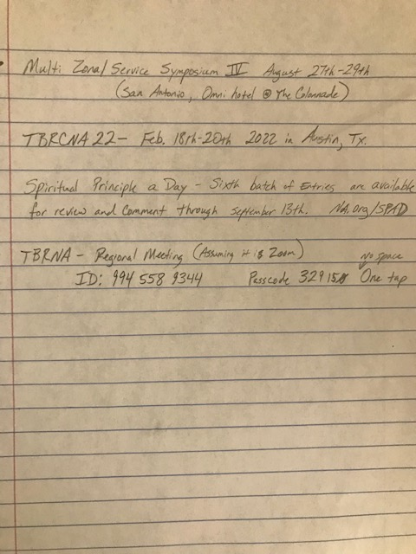

Jeremy gave treasurers report
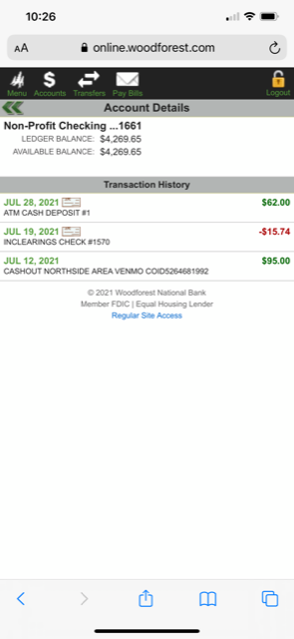
$18 cash collected in 7th Tradition Basket

Robert gave H&I Report
Two meetings a week. Robert, Billy Holliday Tuesaday 3:30
Scott Luther 5 pm
Robert will follow up with the guy who has some rehabs and is looking for meetings
First H&I in person meeting after this ASC

Web Servant
Steve has done some moving around on website. Moved groups to top. Steve and Ron have had a meeting to show Ron the ropes.
Sent Show Up and Grow Up info to World.

Activities Report
Glenna No written report.
FBTL Breakfast WOODNA
Lunch BLTN
Snacks SUGU 3-5, New Hope 1-3
Dinner RIP
HJF Desserts
Has scheduled a speaker
Will plan an in person Activities meeting on Monday 16 7:15pm after Meeting at BLTN
Glenna is going to start planning for groups to start fundraising for next year FBTL
Ashley from Cypress said their Group is interested in doing a fundraiser
Activities will begin the process of securing campsites for next year.

Break

Group reports
BLTN
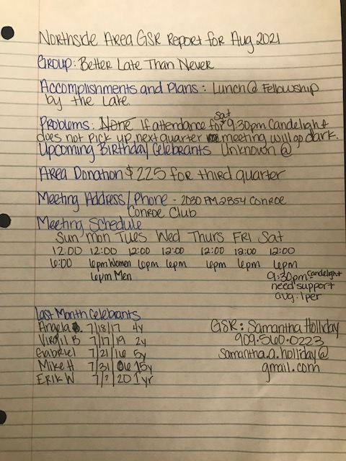

Cypress Group
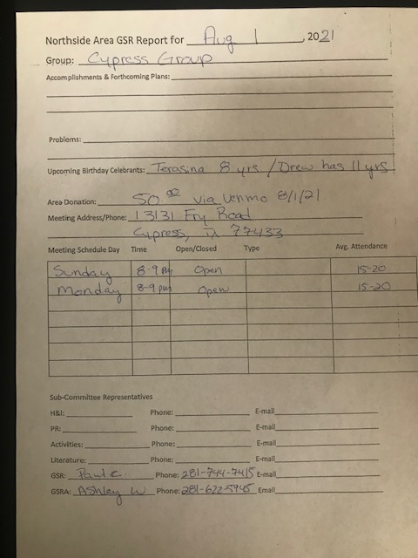

New Hope
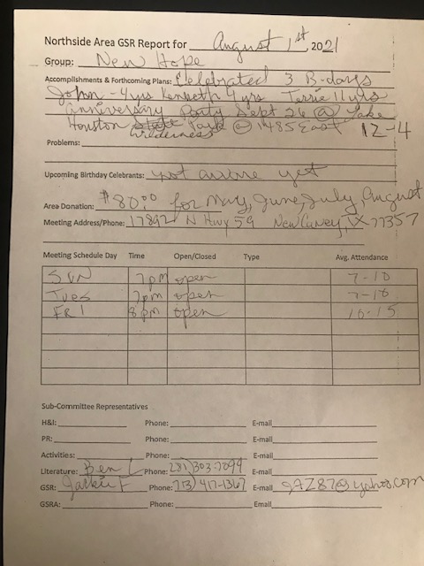

RIP Group
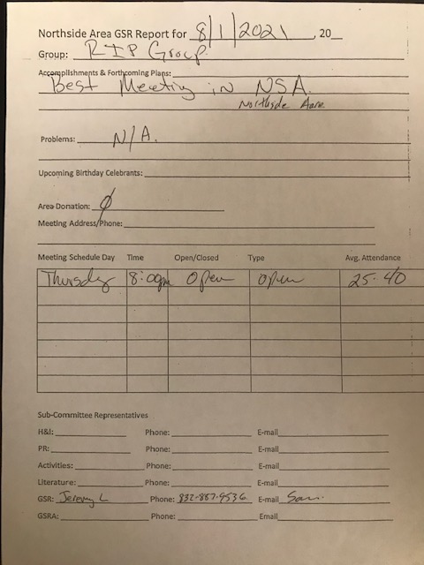

Woodlands Group
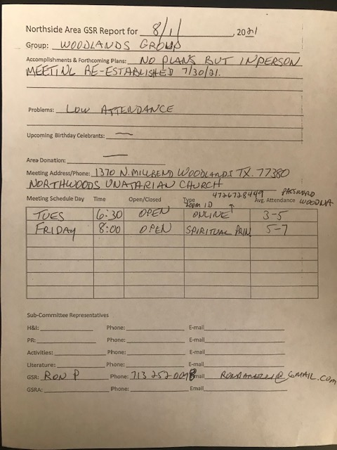

Sharing
Scott said that schedules are ordered From Hascona
Larry wants to do a an H&I flyer – will get some input from Robert and the H&I subcommittee
Larry will reach out to DON about a check that Jeremy said he didn’t receive

No old business
New Business
Activities sub committee meeting Monday Aug 16 at 7:15 at BLTN
Next ASC Sep 12
Close

