Area RCM 2 report to NASCONA

Brian N 832-610-4511 electric.newbury@gmail.com

Greetings,
As of this day, the NASCONA RCM 1 position is open for nominations as Mikala H has resigned from this service position.
Below is a list of activities that occurred during this RSC.
Convention Planning;
A proposal to absorb the convention advisory committee, “CAC” into a standing hotel liaison committee was discussed and passed. This should allow for more participation from members with interest to serve as conventions are being planned without extended term commitments.
Nominations are open for trusted servants for the committee however each must be present and provide a service resume.
Finances;
The region reported a working balance of 19,819.75 of which the following disbursements were made.
Group liability insurance fees – 5,185.00 ,this left 14,634.75 of which 12,886.24 was the check sent by the former treasurer as restitution for funds misappropriated for personal use that were to be directed to NAWS.
A thank you letter will be drafted to be reviewed and sent to the former treasurer recognizing this restitution as received along with well wishes from our region as proposed by the areas.
A check matching this amount was sent to NAWS as agreed leaving a balance of 1,748.51.
A drop box account reimbursement was authorized for the amount of 25.00 and a 20% quarterly contribution to NAWS ultimately left a working balance of 814.69 by the end of the RSC.
7TH tradition contributions: To further align with the Regional Policy contributions to AAI will no longer be separately marked as the region is fully self supporting and supports AAI through 7th tradition contributions from each area. The 7th tradition donation language will be changed on the Regional Website to reflect this alignment.
For example Cypress group made a contribution of $99.00 to region collected from an AAI contribution can that was passed apart from the groups seventh tradition. Although each group is autonomous such funds do not go directly to AAI but are added to general funds which supports the AAI committee needs.
Cypress group has since decided to no longer pass the AAI can as it would be misleading as direct support.

The next Reginal Service Committee will meet via ZOOM February 13th 2021.
Public Relations Facilitator , Regional co treasurer and Hospitals and institutions have openings for nominations.

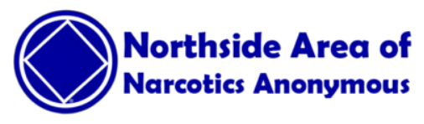
Northside Area Service Committee of NA (NASCONA) meets virtually on the 1st Sunday at 1:15 PM- 4:15 PM, Meeting ID 3113644618 Password 244910
IL&S Brian N (832)610-4511
RCM 2 NASCONA

