NASCONA RECORDINGS
December 6th, 2020
Northside Area Service Committee of NA (NASCONA) meets virtually on the 1st Sunday of each month at 1:15 PM- 4:15 PM, Zoom Meeting ID 3113644618 Password 244910
The Northside Area Service Committee opened with the Serenity Prayer at 1:15 PM by the Area Facilitator.
Traditions read by; Jeramy L.
Concepts read by Paul C.
Purpose of the ASC read by Larry M.

Service Prayer read by; Jeramy L.

Group Roll Call Service Body Roll Call
- Facilitator_ Present
- Co-facilitator_ Open
- Recorder_ Absent
- RCM_1_Open
- RCM_2_Present
- H&I_ Absent
- Treasurer_ Present
- Co-treasurer_ Open
- Web Servant_ Absent
- PR_ Present
- Activities_ Absent
- Lit Review_ Open
- BAM_ Absent
- BLTN _ Present
- Cypress Group of NA _ Present
- Happy Joyous and Free_ Absent
- Hope Without Dope_ Absent
- New Hope_ Absent
- Recovery in Progress _ Present
- Serenity Happens _Absent
- Serious Undertakings _ Present
- Woodlands NA_ Absent
- Show up to grow up _Present
Five Groups Marked as present.
Service Committee Reports:
Recorder: Due to the recorder being absent for this ASC roll call was performed by the treasurer from previous recordings. Last email from the recorder was sent Dec 3rd “Hey guys I am trying to get the recordings put together from last month. I cannot locate the notes I have taken”. I also cannot remember much these days......Can some of you email a recap of the meeting please??? Thanks in advance!!!
Treasurer: Reported a working balance of 3,435.96 report was sent electronically to the 0123-distribution e-mail. Report accepted
RCM 2: Report sent to 0123
The next Reginal Service Committee will meet via ZOOM February 13th, 2021.
Public Relations Facilitator, Regional co treasurer and Hospitals and institutions have openings for nominations nominees must be present and submit service resumes to.
Tejas Bluebonnet Region all@tbrna.org
Report was read and accepted.
H&I: Absent.
Public Relations: PR REPORT verbally submitted by Tod B.
Not much to report however is considering distributing newcomer packets to the P.A.R.C. prevention and recovery center.
Todd B Toddb3.tb@gmail.com 832-482-5913
Activities: Absent.
Note the $90.00 refund from the cancelled campsites purchased has not been received as of this ASC.
Web Servant: Absent, please note that the following members have requested to be removed from the 0123-distribution list, Alicia R aliciarichards24711@gmail.com Sara Arnold syrup79@gmail.com

Literature Review: Open Position

Group Reports:
BLTN: Present
Problems: None Meeting address 2030 FM 2854 Conroe TX,
Mon | Noon & 6PM | Open/closed | Step study/Men’s/Women’s
Tues | Noon & 6PM | Open/closed | Discussion/Lit Study
Wed | Noon & 6PM | Open/Open
Thurs | Noon & 6PM | Open/closed | Discussion/Living Clean Study
Fri | Noon & 6PM | Open/Open
Sat | Noon ,6PM & 9:30PM | All open
Sun | Noon & 6PM | All open
Reported an ASC a contribution of $450.00 for Oct -Dec.
Cypress Group: Present
Location 13131 Fry Rd Cypress TX, 77433
Meetings are in person.
Sun | 8PM | Open | Discussion | 4-6
Mon | 8PM | Open | Lit Study | 6-10
Paul C mentioned that Cypress group will be chairing a three-hour time block via zoom for the annual Christmas Marathon meeting hosted by the Third Coast Group Christmas Day 11-2pm see flyer snip below. ASC contribution = $78.00
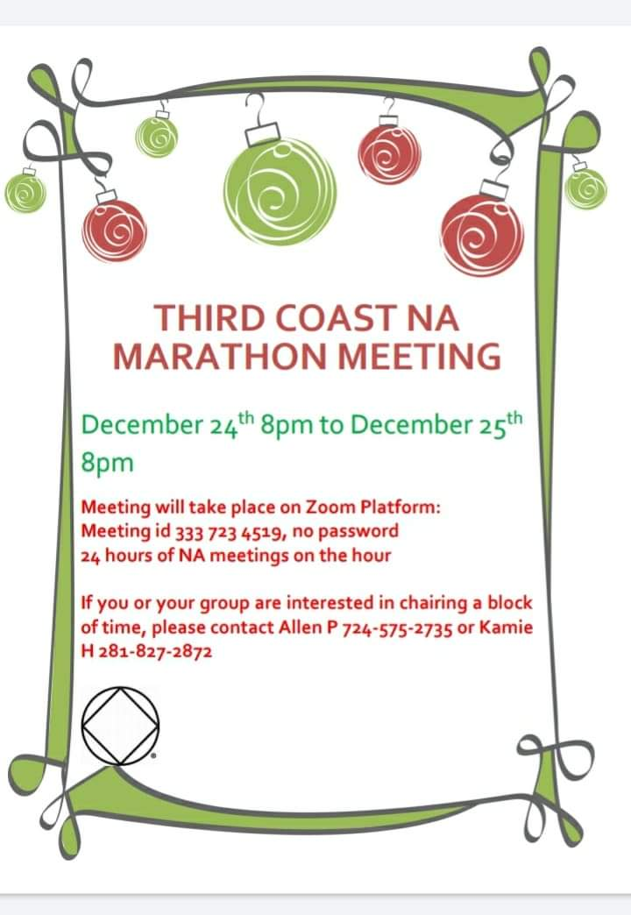
New Hope; Absent
Location is 17892 US HWY 59 Meetings are held on the following days with adv attendance.
Sun | 7PM | Open | Discussion | 6
Tues | 8PM | Open | Lit Study | 8
Fri | 8PM | Open | Discussion/B-day night. | 8

Recovery in Progress: Present
Bonfire Meetings!
Third Annual Christmas Party December 10th starting at 6pm flyer shared to 0123. Location 10224 Fairview Dr. Conroe TX, 77385
Flyer snip below…
ASC Donation $46.00
Thurs | 8PM | Open | Discussion | 20-40 in attendance
RIP Meets regularly at 608 Cactus in Conroe 77385 Thursdays at 8PM
Happy Joyous and Free: Absent
Meetings are held regularly at The Woodlands United Methodist Church 2200 Lake Woodlands Dr. The Woodlands TX, Rm D211 at 7:00 PM attendance average of 10-25.
Mon | 8PM | Open | Discussion | ?
Hope without Dope; Absent
2nd Baptist Church Kingwood FLC building rm 202.
Mon | 8PM | Open | Open Discussion | ?
Thurs | 8PM | Open | Open Discussion | ?

Woodlands NA: Absent
Tues | 6:30 | Open | Leaders choice | ?
Fri | 8PM | Open | Spiritual principles | ?
2nd Fri | 7PM | Open | Business meeting | ?
Come and join us Fridays at 8:00pm and Tuesdays at 6:30pm. 1202 N Mill bend rd. Spring TX, 77380
Serious Undertakings: Present
At Serious Undertakings, we are continuing our virtual meetings via Zoom. We currently meet on Sundays at 7:00pm for a literature study and on Thursdays at 8:00 pm for a topic discussion. The zoom ID # 856-6024-0048 and the password is: recovery. Participation has increased slightly, and we have averaged 4 attendees.
We are having a face-to-face hybrid meeting on Thursdays at 8:00 pm at Kate Barr Ross memorial park. 486 TX-75 N Huntsville TX.
Thurs | 8PM | Open | Hybrid | 6
Sun | 7PM | Open | Zoom | 6
Serenity Happens: Absent.
Mon | 8PM | Open | Discussion | ?
Tues | 8PM | Open | Discussion | ?
Wed | 8PM | Open | Discussion | ?
Thurs | 8PM | Open | Discussion | ?
Fri | 8PM | Open | Discussion | ?
Sun | 4PM | Open | Discussion | ?
1403 W. Main St, Navasota TX,
Show up to grow up:
Problems: still not listed on the calendar link on the NASCONA website.
Meeting in person. Averaging 12 to 15 people per meeting.
Wed | 7:30 PM | Open | Discussion | 12-15

ASC Contribution = $20.00 pending
Upcoming Celebrants- None
Meeting Location: Faith United Methodist Church 2403 Rayford Rd Spring, TX 77386

Open Sharing /discussion session:
Discussion for H&I support regarding opportunities to provide literature to Montgomery County, Walker County and Pac One units. Suggestion to use the 542.00 available to send shipment of paperback Basic Texts to each facility.
Suggestion to follow up with requests and verify if newcomer packets could be distributed as well with assistance from PR.
Financial discussion.
Area is seeking re-imbursement from the campsite cancellations from the Activities Chair.
Please provide receipt of re-imbursement – cancellation charges.
The $120 contribution - $10 cancelation fees per site = $90.00 past due.

Old business: Elections.
No volunteers or nominations to fill open positions.
- Area Facilitator = Larry M
- Area Co-Facilitator = Open
- Area Treasurer = Jeramy L
- Area Co treasurer = Open
- Area Recorder = Jennifer P? Open?
- Area H&I facilitator = Robert H
- Area PR facilitator = Todd B
- RCM 1 = Open
- RCM 2 = Brian N
- Area Activities Facilitator = Glenna K
- Area Literature Review = Open
Next ASC is January 10th at 1:15PM due to the New Year weekend. Zoom Meeting ID 3113644618 Password 244910
Meeting closed at 3:00 pm with the third step prayer.

